Java Game Suite

CMSC 495 6382

October 10, 2021

Team Charlie

Sherry Funches, Oyewole Sanusi, Janee’ Jones, Wayne Mack, Jeffrey McGlinn

**TABLE OF CONTENTS**

1. Overview 4

1.1 Development Team Contributions 4

2. Project Plan 4

2.1 Revision History 4

2.2 Overview 5

2.2.1 Product Description 5

2.2.2 User Characteristics 5

2.2.3 User Scenarios 5

2.3 Requirement Specifications 6

2.4 System Specification 8

2.5. Software Management 9

2.6 Project Schedule 10

2.7 References 12

3. User Guide 13

3.1 Revision History 13

Introduction 14

System Requirements 14

Installation 15

Operation 15

1. Maze 15

2. Snake 17

3. Sudoku 18

4. Word search 22

5. Slider Puzzle 25

4. Test Plan, Results, and IWD 30

4.1 Revision History 30

4.2 Test Plan and Results 31

A. Main Menu 31

B. Maze 32

C. Snake 33

D. Sudoku 34

E. Word Search 35

F. Slider Puzzle 40

4.3 Inner Working Details (IWD) 41

4.4 Context Diagram 43

4.5 References 43

5. Design and Alternate Designs 44

5.1 Revision History 44

5.2 Class Diagram 45

Main Menu 45

Maze 46

Snakes 47

Sudoku 48

Word Search 49

Slider 50

5.3 Sequence Diagrams 51

Start-up Scenario: 51

Shut-down Scenario: 51

Normal Operation Scenario: 52

Error-Handling Scenario 1: 53

Error-Handling Scenario 2: 55

Error-Handling Scenario 3: 56

5.4 Pseudo Code / Code 57

Main Menu: 57

Maze: 57

Snake: 61

Sudoku: 63

Word Search 75

Slider Puzzle 80

5.5 References 84

6. Development History 85

6.1 Revision History 85

6.2 Team Milestones 88

6.3 Phase 1 Report 89

A. Maze 89

B. Snakes 89

C. Sudoku 90

D. Word Search 94

E. Slider Puzzle 96

6.4 Phase 2 Report 100

A. Maze 100

B. Snakes 101

C. Sudoku 101

D. Word Search 103

E. Slider Puzzle 104

6.5 Phase 3 Report 106

A. Maze 106

B. Snakes 108

C. Sudoku 108

D. Word search 111

E. Slider Puzzle 113

F. Main Menu/ Game Integration 116

6.6 Phase 4 Report 117

A. Testing 117

B. Additional Notes on Individual Programs 117

7. Conclusions and Lessons Learned 120

# 1. Overview

The Java Game Suite program is a simple GUI-based application that provides entertainment to users by allowing them to play several simple single-player computer games. The user will be presented with an interface that indicates the available games: a maze, snakes, Sudoku, word search, and a slider puzzle. The user will be able to select a game from the suite and launch it from that interface.

## 1.1 Development Team Contributions

* Oyewole Sanusi - Snake
* Sherry Funches – Word Search
* Janee’ Jones - Sudoku
* Wayne Mack – Main Menu and Maze
* Jeffrey McGlinn – Slider Puzzle

# 2. Project Plan

## 2.1 Revision History

|  |  |  |  |
| --- | --- | --- | --- |
| **Revision Number** | **Date** | **Description** | **Name** |
| 1 | 8/27 | Creation of Doc and Outline | Oyewole |
| 2 | 8/28 | System Specification | Oyewole |
| 3 | 8/28 | Software Management | Oyewole |
| 4 | 8/29 | Requirement Specifications | Oyewole, Sherry, Wayne, Janee’, Jeff |
| 5 | 8/29 | Added use cases, requirements, team member assignments to tasks | Sherry |
| 6 | 8/29 | Moved User Guide and Test Plan to Week 3 | Sherry |
| 7 | 8/29 | Modified details for the Maze portion and checked the document for errors. | Wayne |
| 8 | 8/30 | Checked document for errors | Janee’, Jeff |
| 9 | 10/10 | Updated Sudoku User Scenario and Requirement Specifications | Janee’ |

## 2.2 Overview

### 2.2.1 Product Description

The purpose of this software package is to provide entertainment to users by allowing them to play several simple single-player computer games.

### 2.2.2 User Characteristics

The user will have basic computer competencies such as being able to operate a mouse and keyboard. Elementary math abilities are required to play Sudoku.

### 2.2.3 User Scenarios

#### 2.2.3.1 Launching the Program

When the user wants to play a game from the suite, they will launch the program. They will be presented with an interface that indicates the available games: a maze, snakes, Sudoku, word search, and a slider puzzle. The user will be able to select a game from the suite and launch it from that interface.

#### 2.2.3.1 Maze

The user will select a maze to play. They will then use their keyboard to move their character through the maze to the end goal. The user will be able to see how much time it took to complete the maze. The user potentially may have to avoid obstacles or enemy characters. The user can select a new game when finished.

#### 2.2.3.2 Sudoku

The user first will be presented a game. All the games will be intermediate for the difficulty level. The user will be presented with a 9 x 9 grid subdivided into 9 3 x 3 grids. Some of the cells will be filled in with numbers and the rest will be blank. The user will start to solve the puzzle by entering a number into one of the blank cells. The system will alert the user if the number they entered is incorrect. Once the game is complete the user will be able to check the answers. The user will be able to select a new game or exit the game and select a new game from the main menu.

#### 2.2.3.3 Word search

First, the user will select a puzzle based on a theme, such as animals or places. The user will then be presented with a grid of letters and a list of the words that they must find in the grid. The user will mark on the grid the words that they find in the list. The user will have the option to keep track of the words that they find by marking them off on the provided list. When they believe they are done the user can submit their puzzle. They will be provided with the solution. They will then have an option to restart the puzzle or select a new game. The user will have the ability to remove a mark or clear all markings off of the grid.

#### 2.2.3.4 Snake

The user will indicate to the system that they are ready to play the game. They will be presented with a snake enclosed in a rectangle that is in continual motion. The user will use their keyboard to maneuver the snake to consume dots inside the enclosure while preventing the snake from eating itself (touching its head to its body). The game will end when the snake eats itself. The user then can restart the game.

#### 2.2.3.5 Slider Puzzle

When the user launches the program they will be presented with a reference image and twelve scattered tiles. The user will slide the tiles around until they are able to recreate the original image. The user can change the puzzle.

## 2.3 Requirement Specifications

|  |  |
| --- | --- |
| **Requirement Number** | **Description** |
| 1 | This suite will have a minimum of 5 mini games to try out. |
| 2 | Five games that will be in the suite:   1. Maze 2. Sudoku 3. Word search 4. Snake 5. Slider puzzle |
| 3 | Launching the Program:  The system will provide an interface in which the user can select a game.  The system will launch the selected game from that interface.  The system will allow the user to return to the main interface at any time and to select a new game. |
| 4 | Maze Game:  The system will have built in maze levels that become progressively larger and features more obstacles  The system will allow the user to maneuver their character through the maze using keys on their keyboard (arrow keys or WASD.)  The system will display to the user the time it took to complete the maze if successfully completed and maintain a leaderboard for every level.  The system will allow the user to replay a completed maze.  The system will allow the player to advance to the new maze  Potential Features:  The system will present obstacles within the maze that the user must avoid.  The system may present enemy characters that could pursue the user through the maze. |
| 5 | Sudoku:  The system will be an intermediate difficulty level across all the game boards.  The user will be able to enter a number into a blank cell.  The system will check each number as it is inserted.  The system will inform the user that a number is correct or incorrect.  The system will allow the user to restart the game.  The system will allow the user to exit the game and select a new game. |
| 6 | Word search:  The system will allow the user to select a theme for a game.  The system will allow the user to select a new game corresponding to the theme.  The system will display a grid of letters.  The system will display a list of words hidden in the grid.  The system will allow the user to optionally mark off words from the list.  The system will allow the user to mark on the grid the words that they find.  The system will allow the user to submit the puzzle when complete.  The system will respond to the user if they were successful or provide the correct solution.  The system will allow the user to remove the last mark on the grid.  The system will allow the user to remove all marks on the grid. |
| 7 | Snakes:  The system will provide the user an option to start the game.  The system will provide a GUI with a snake enclosed in a rectangle/square.  The snake will be in constant motion.  The system will provide dots or shapes the user will maneuver the snake to eat.  The game will end when the snake consumes itself.  The system will allow the user to maneuver the snake using their keyboard.  The system will provide an option to reset the game when the game ends. |
| 8 | Slider Puzzle:  The system will initially present the user with a new puzzle.  The system will provide the user with an image of the solution/original picture as reference.  The system will divide that image into twelve scattered tiles.  The system will allow the user to slide the tiles to form the original image.  The system will allow the user to change the reference image. |

## 2.4 System Specification

**Development Platform**

|  |  |
| --- | --- |
| OS | Windows 10 / Mac OS |
| Processor | Intel Core i5 4.1GHz |
| Development Software | Apache Netbeans 11.3 / Intellij IDEA 2020.2 / Java JDK 9 |
| Memory | 8 GB RAM |
| Storage | At least 4.0 GB of disk space |

**Production Platform**

|  |  |
| --- | --- |
| OS | Windows 7 or better, Mac OS |
| Processor | 1.8 GHz or faster |
| Storage | At least 4.0 GB of disk space |

## 2.5. Software Management

Version control will be handled through a repository at GitHub. The link for the project repository is:

<https://github.com/tsanusi/CMSC495-Group-Charlie-Java-Game-Suite>

This repository will hold all documents relating to the project, as well as all versions of the project. It is publicly accessible. Please refer to README in the repository for more information.

## 2.6 Project Schedule

|  |  |  |  |  |
| --- | --- | --- | --- | --- |
| **Task** | **Duration(days)** | **Start Date** | **End Date** | **Personnel** |
| 1. Project Requirements    1. Requirement Specifications    2. System Specification    3. Software Management    4. Project Schedule    5. Group Revision | 7  5  5  5  5  2 | 8/23  8/25  8/25  8/25  8/25  8/28 | 8/29  8/29  8/29  8/29  8/29  8/29 | Oyewole, Sherry, Janee’, Wayne, Jeffrey  Oyewole, Sherry, Janee’, Wayne, Jeffrey  Oyewole, Sherry, Janee’, Wayne, Jeffrey  Oyewole, Sherry, Janee’, Wayne, Jeffrey |
| -Week 3- |  |  |  |  |
| 1. Project Analysis    1. Context Diagram    2. Inner Working Details    3. Test Plan    4. User Guide    5. Group Revision | 7  5  5  5  5  2 | 8/30  8/30  8/30  8/30  8/30  9/4 | 9/5  9/3  9/3  9/3  9/3  9/5 | Janee’  Janee’  Sherry  Oyewole  Oyewole, Sherry, Janee’, Wayne, Jeffrey |
| -Week 4- |  |  |  |  |
| 1. Project Design    1. Class Diagram    2. Sequence Diagram    3. Pseudo Code    4. Performance Estimates    5. Group Revision | 7  5  5  5  5  2 | 9/6  9/6  9/6  9/6  9/6  9/11 | 6/15  9/10  9/10  9/10  9/10  9/12 | Wayne  Jeff  Oyewole, Sherry, Janee’, Wayne, Jeffrey  Oyewole  Oyewole, Sherry, Janee’, Wayne, Jeffrey |
| -Week 5- |  |  |  |  |
| 1. Project Test Plan & ICD    1. Test Plan    2. Interface Control Document (ICD)    3. Group Revision | 7  5  5  2 | 9/13  9/13  9/13  9/18 | 9/19  9/17  9/17  9/19 | Sherry  Janee’  Oyewole, Sherry, Janee’, Wayne, Jeffrey |
| -Week 6- |  |  |  |  |
| 1. Implementation and Testing (Sprint 1)    1. GUI coding    2. Other Required Classes coding    3. Testing    4. Group Revision | 7  5  5  5  2 | 9/20  9/20  9/20  9/20  9/25 | 9/26  9/24  9/24  9/24  9/26 | Oyewole, Sherry, Janee’, Wayne, Jeffrey  Oyewole, Sherry, Janee’, Wayne, Jeffrey  Oyewole  Oyewole, Sherry, Janee’, Wayne, Jeffrey |
| -Week 7- |  |  |  |  |
| 1. Further Implementation and Testing (Sprint Two)    1. Further coding    2. Testing    3. User Guide    4. Group Revision | 7  5  5  5  2 | 9/27  9/27  9/27  9/27  10/2 | 10/3  10/1  10/1  10/1  10/3 | Oyewole, Sherry, Janee’, Wayne, Jeffrey  Oyewole, Sherry, Janee’, Wayne, Jeffrey  Oyewole  Oyewole, Sherry, Janee’, Wayne, Jeffrey |
| -Week 8- |  |  | Due Early for Peer Review (Saturday 10/9) |  |
| 1. Final Sprint - Delivery    1. Finishing Touches    2. Update all Documents with any Changes    3. Group Revision | 5  3  3  2 | 10/4  10/4  10/4  10/7 | 10/8  10/6  20/6  10/8 | Oyewole, Sherry, Janee’, Wayne, Jeffrey  Oyewole, Sherry, Janee’, Wayne, Jeffrey  Oyewole, Sherry, Janee’, Wayne, Jeffrey |

## 2.7 References

U.S. General Services Administration. (2021, October 10). *Scenarios*. Useability.gov. <https://www.usability.gov/how-to-and-tools/methods/scenarios.html>

# 3. User Guide

## 3.1 Revision History

|  |  |  |  |
| --- | --- | --- | --- |
| **Version** | **Date** | **Comments** | **Author** |
| 1 | 31 August 2021 | First version of user guide created | Oyewole |
| 2 | 4 September 2021 | Added snake instructions | Oyewole |
| 3 | 4 September 2021 | Added slider puzzle instructions | Jeff |
| 4 | 5 September 2021 | Added word search instructions | Sherry |
| 5 | 5 September 2021 | Added Sudoku instructions | Janee’ |
| 6 | 5 September 2021 | Added Maze gameplay guide | Wayne |
| 7 | 5 September 2021 | Combined and formatted individual game instructions into a unified document | Sherry |
| 8 | 6 September 2021 | Changed and unified fonts and numbering. Fixed copy issues for Sudoku and Slider puzzle puzzles. Added page numbers in table of contents for games. Grammar/spelling edits. | Sherry |
| 9 | 6 September 2021 | Checked document for errors | Oyewole, Sherry, Wayne, Janee’, Jeff |
| 10 | 9 September 2021 |  | Jeff |
| 11 | 9 October 2021 | Updated images and changed wording for Word Search | Sherry |
| 12 | 9 October 2021 | Updated Sudoku by removing the ‘Exit’ button and wording | Janee’ |
| 13 | 10 October 2021 | Updated snake instructions to reflex new changes | Oyewole |

## Introduction

1. The Java Game Suite program is a simple GUI-based application that provides entertainment to users by allowing them to play several simple single-player computer games. The user will be presented with an interface that indicates the available games: a maze, snakes, Sudoku, word search, and a slider puzzle. The user will be able to select a game from the suite and launch it from that interface.

# 

## System Requirements

Java Game Suite Minimum System Requirements:

1. **Operating System:** Mac, PC, or Linux
2. **Memory:** Minimum of 128 MB RAM
3. **Processor:** Pentium 266 MHz processor or faster
4. Latest version of Java compatible with your OS. ([Link](https://www.java.com/en/download/manual.jsp))

# 

## Installation

1. Source code can be downloaded from the following link: [Java Game Suite](https://github.com/tsanusi/CMSC495-Group-Charlie-Java-Game-Suite.git)

2. Navigate to the saved destination of the code and extract the zip file contents.

3. Navigate into the /disk directory and double click on the Main executable

File to run the program.

# 

## Operation

### 1. Maze

A. Select “Maze” from the menu to launch the game.

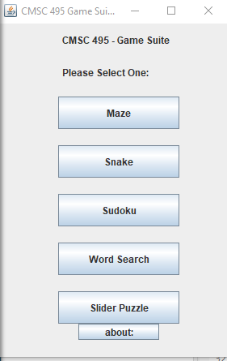

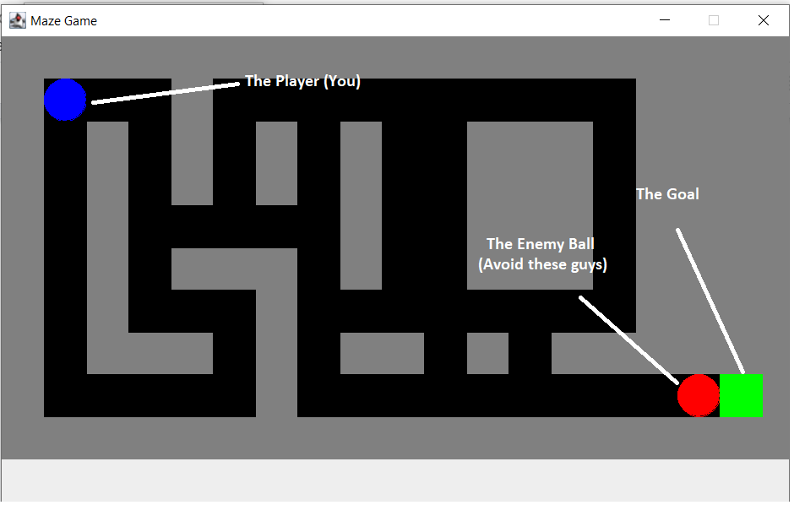

Note: Game is still being coded. The final product will vary from this instance.

The goal of each level is to help the player (the blue dot) to the exit (the green block) while evading the baddies (the red dots). You have an unlimited number of lives but your final standings will take the number of deaths into consideration so make sure you avoid death as much as possible. You control the player with the arrow keys. Alternatively, you can also use W, A, S, D as both will work. If you are hit by any enemy, the maze level starts again and you will have gained a death point. The score at the end is based on how much time it takes to complete the mazes and the number of deaths the player has received.

GOOD LUCK!

### 2. Snake

A. Select “Snake” from the menu to launch the game.



B. The game starts immediately:

* The user will maneuver the snake to eat the apples
* The user maneuvers the snake using the following keys on their keyboard (←, ↑, →, ↓).

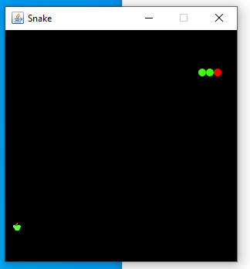

C. The game will end when the snake consumes itself or hits the border.

* Game will need to be relaunched to play again.

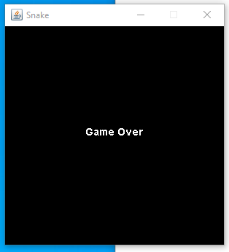

### 3. Sudoku

A. Select “Sudoku” from the menu to launch the game.



1. The game will open for the user to play:

* 2 options will be displayed to the user: “New” “Check”
* New: will allow user to select a new game
* Check: will allow user to check answers
* End Game: User will press the ‘X’ in the top right corner to exit the game and go back to main menu to select a new game to play.

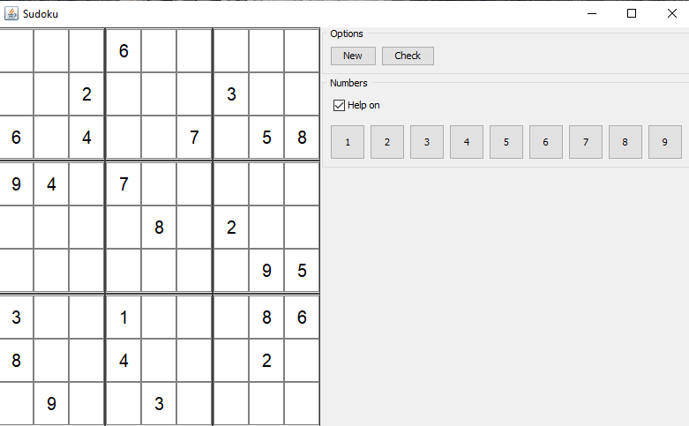

1. User will select a number i.e. “1”. All the locations where a 1 can go will be displayed in blue. The user will be able to click on the box that they want the 1 to go. The blue display is annotated by the “Help on” check box. User will be able to turn this on or off depending on if they want the help. User will proceed with each number with the same concept.

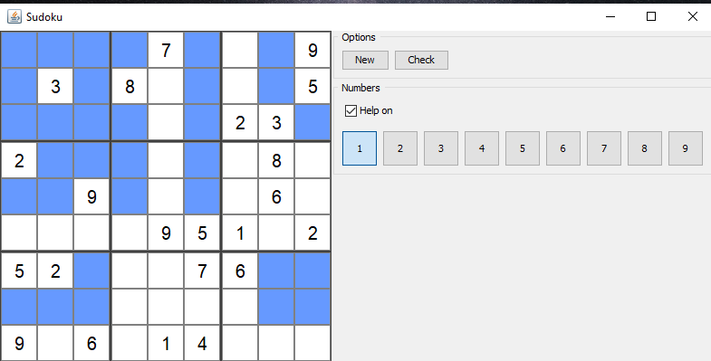

1. Once a number is entered by the user the blue display boxes will go away and that number has been entered.

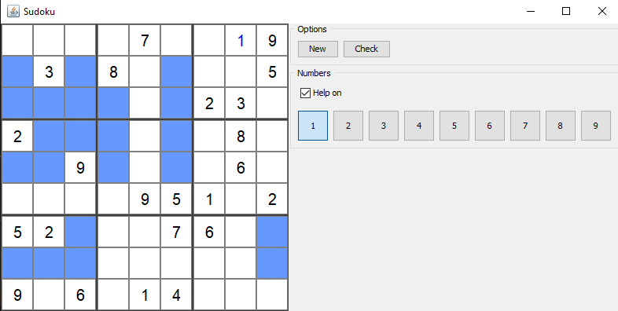

1. User will be able to click the check button to see their progress and check the location of the numbers that were entered on the board. If a red block is displayed this means that a number was entered wrong in that location. Once the correct number is entered the block will change to green.

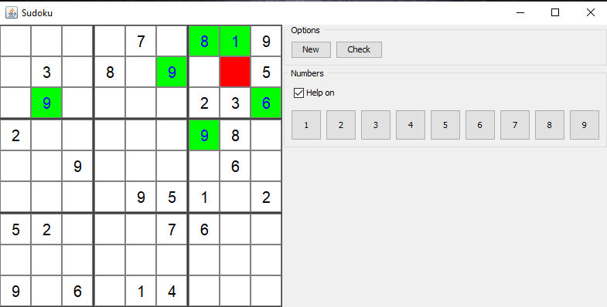

1. This shows that the user has completed the game. To start a new game user can click on the “New” button for another board to be displayed. To exit the game user will click “X” in the top right corner and game will close and lead back to the main menu. 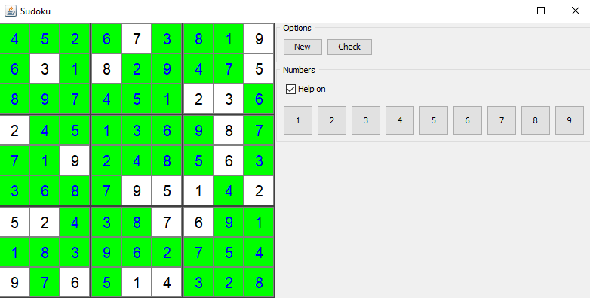

### 4. Word search

A. Select “Word Search” from the menu to launch the game.



1. To start a new game select a puzzle by clicking on the button labeled “Select Puzzle.” Then choose a puzzle file from the directory called “WordSearchPuzzles.” Puzzles are named by a theme followed by a game number (i.e. Countries 1). Click on the puzzle file and then on the “open” button to select a puzzle file. Then click on the “Load Puzzle” button to load the puzzle.

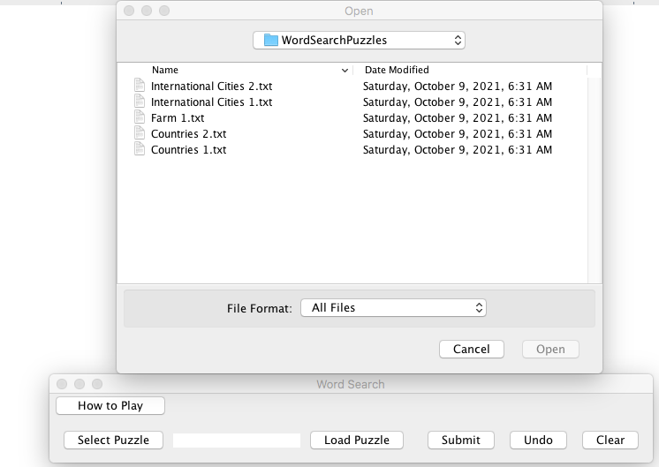

1. Search for the words in the list labeled “Word List” on the right hand side of the screen in the grid of letters at the top of the screen. Words can appear backwards, forwards, vertically, horizontally, and on diagonals.

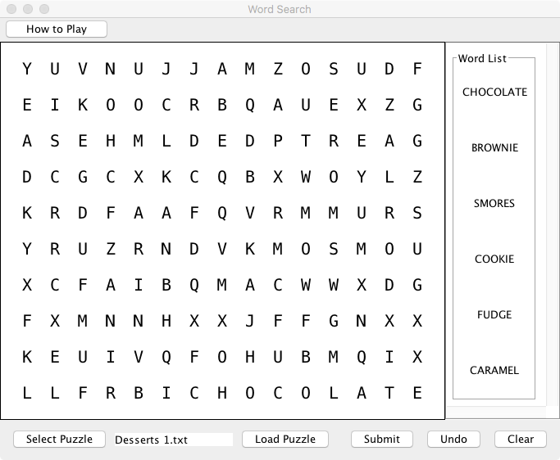

1. Highlight found words by clicking and dragging the mouse across the letters of the word. Valid highlights must intersect the center of each letter in a continuous line. Additionally highlighted letters are invalid.

Valid highlight:

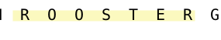

Invalid highlight:



1. Click the “Clear” button to clear the grid of all highlights.
2. Click the “Undo” button to undo the last highlight on the grid.
3. To optionally cross off words from the list as they are found click on the word in the list. To undo the strikethrough click the word again.
4. To submit the puzzle and see the solution click the “Submit” button. All unfound words in the puzzle will appear in red font.

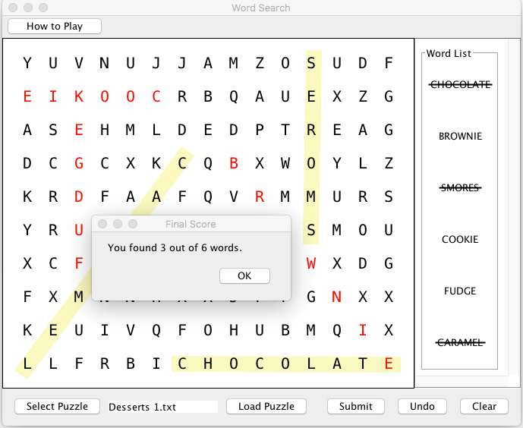

A message will appear informing the user of how many words were correctly identified.

1. Start a new game at any time by following the instructions in Step B.

### 5. Slider Puzzle

A. Select “Slider Puzzle” from the menu to launch the game.



B. Select a new puzzle from the “Choose a puzzle” section of the Slider Puzzle menu.

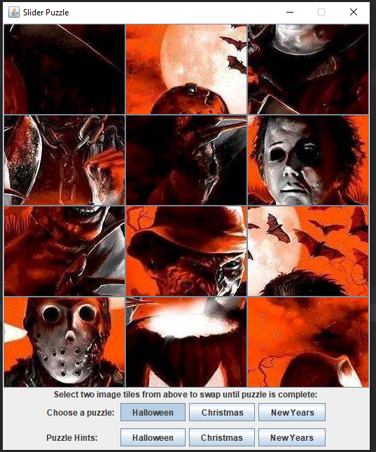

C. Select a puzzle hint, in the “Puzzle Hints” section, to preview the completed puzzle image.

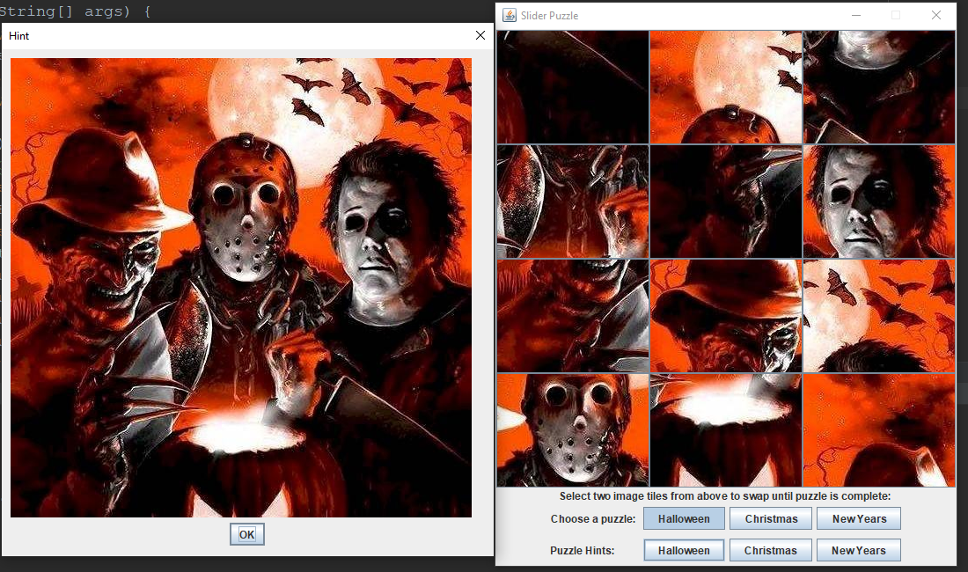

D. Exit the “Hint” window to return to the Slider Puzzle.



1. Select two images that will swap icons until the puzzle is complete. (Note: A message will appear once the puzzle completed).

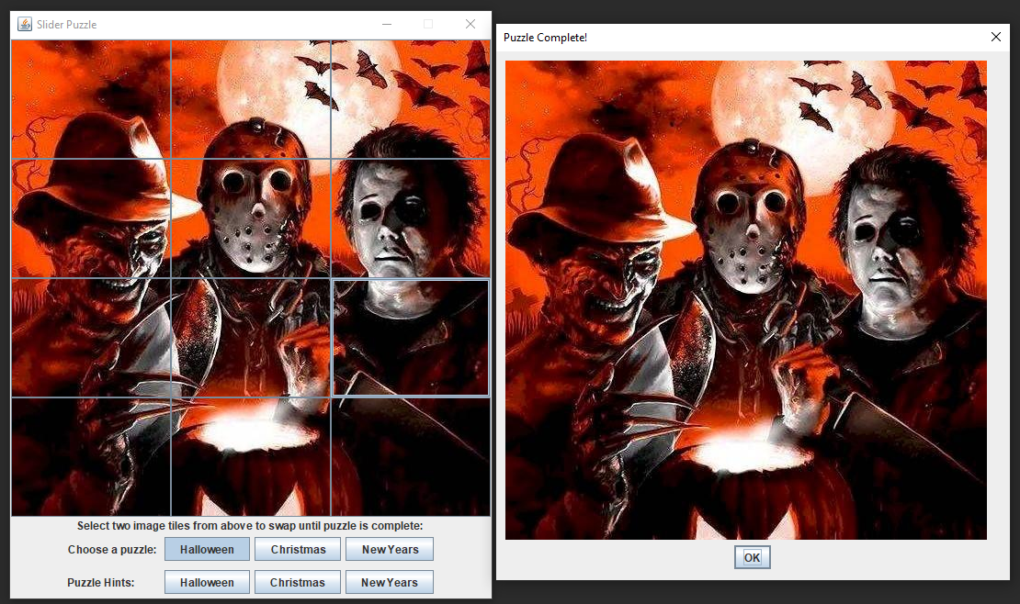

F. Select exit to return to the Game Suite Main Menu.

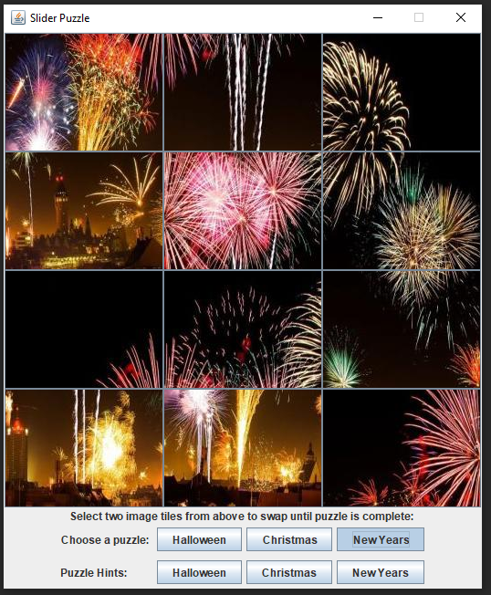

6. Select “about” from the menu to view credit page.



# 4. Test Plan, Results, and IWD

## 4.1 Revision History

|  |  |  |  |
| --- | --- | --- | --- |
| **Revision Number** | **Date** | **Description** | **Name** |
| 1 | 8/30 | Creation of Doc and Outline | Oyewole |
| 2 | 9/4 | Adding Context Diagram and Citations | Janee’ |
| 3 | 9/4 | Add test plan for Snakes | Oyewole |
| 4 | 9/5 | Add test plan for Slider Puzzle and minor edits | Jeff |
| 5 | 9/5 | Add test plan for word search | Sherry |
| 6 | 9/5 | Add test plan for Sudoku | Janee’ |
| 7 | 9/5 | Add test plan for Maze | Wayne |
| 8 | 9/5 | Enter and format all test plans into unified document | Sherry |
| 9 | 9/5 | Updating IWD | Janee’ |
| 10 | 9/6 | Edit and add test cases to Main Menu and Word search. Added Requirements specification numbers | Sherry |
| 11 | 9/6 | Modified details for Test Plan, Removed IWD tables, and Checked for errors | Oyewole |
| 12 | 9/6 | Checked document for errors | Sherry, Wayne, Janee’, Jeff |
| 13 | 9/7 | Added Images for Word search Test Plan |  |
| 14 | 9/7 | Checked document for errors | Sherry, Wayne, Janee’, Jeff, Oyewole |
| 15 | 10/9 | Update Slider Puzzle | Jeff |
| 16 | 10/9 | Update Wordsearch | Sherry |
| 17 | 10/10 | Filled in Results | Sherry |

## 4.2 Test Plan and Results

### A. Main Menu

|  |  |  |  |  |  |
| --- | --- | --- | --- | --- | --- |
| **Test Case Number** | **Requirement Number(s)** | **Test Description** | **Expected Result** | **Actual Result** | **Pass/Fail** |
| 1 |  | Startup of application | GUI in ready state with no unexpected hardware issues or system failure. | GUI was in ready state with no unexpected hardware issues or system failure. | Pass |
|  |  |  |  |  |  |
| 2 |  | User initiated termination of application | Program terminated and all items are deconstructed. | Program terminated properly. | Pass |
|  |  |  |  |  |  |
| 3 |  | About button displays information about the game package | Clicking the “about” button displays information about the game package. | Clicking the “about” button displayed information about the game package. | Pass |
|  |  |  |  |  |  |
| 4 | 2,3 | Maze button launches maze game in a new window | Clicking the maze button launches the maze game in a new window. | Clicking the maze button launched the maze game in a new window. | Pass |
|  |  |  |  |  |  |
| 5 | 2,3 | Snake button launches snake game in a new window | Clicking the snake button launches the snake game in a new window. | Clicking the snake button launched the snake game in a new window. | Pass |
|  |  |  |  |  |  |
| 6 | 2, 3 | Sudoku button launches Sudoku game in a new window | Clicking the Sudoku button launches the Sudoku game in in a new window. | Clicking the Sudoku button launched the Sudoku game in a new window. | Pass |
|  |  |  |  |  |  |
| 7 | 2, 3 | Word search button launches word search game in a new window | Clicking the word search button launches the word search game in a new window. | Clicking the word search button launched the word search game in a new window. | Pass |
|  |  |  |  |  |  |
| 8 | 2, 3 | Slider button launches slider game in a new window | Clicking the slider button launches the slider puzzle game in a new window. | Clicking the slider button launched the slider puzzle game in a new window. | Pass |

### B. Maze

|  |  |  |  |  |  |
| --- | --- | --- | --- | --- | --- |
| **Test Case Number** | **Requirement Number(s)** | **Test Description** | **Expected Result** | **Actual Result** | **Pass/Fail** |
| 1 |  | Startup of Program | Program Starts from main menu | Program executed from main menu | Pass |
|  |  |  |  |  |  |
| 2 | 4 | Control Scheme | Program Controls with keyboard arrows | Program controlled with keyboard arrows | Pass |
|  |  |  |  |  |  |
| 3 | 4 | Alternate Control Scheme | Program Controls with W,A,S,D Characters | Game responded with W,A,S,D characters | Pass |
|  |  |  |  |  |  |
| 4 | 4 | Enemy AI | Enemy responds to AI | Enemy responded to AI | Pass |
|  |  |  |  |  |  |
| 5 |  | Screen Refresh | Screen refreshes seamlessly | Screen can be sluggish but generally is fine | Pass |

### C. Snake

|  |  |  |  |  |  |
| --- | --- | --- | --- | --- | --- |
| **Test Case Number** | **Requirement Number(s)** | **Test Description** | **Expected Result** | **Actual Result** | **Pass/Fail** |
| 1 |  | Startup of application | GUI in ready state with no unexpected hardware issues or system failure. | Game starts immediately. | Pass |
|  |  |  |  |  |  |
| 2 |  | User initiated termination of application | Program terminated and all items are deconstructed. | The APP ends by closing window. | Pass |
|  |  |  |  |  |  |
| 3 | 7 | User maneuvers the snake using keys on their keyboard (←, ↑, →, ↓). | Snake moves up using the ↑ arrow, down using the ↓, left using the ←, and right using the → arrow on the keyboard. | Snake moves up, down, left, and right using the following keys on the keyboard. ((←, ↑, →, ↓) | Pass |
|  |  |  |  |  |  |
| 4 | 7 | Apple is consumed and the snake length increases by one dot. | Apple is consumed and the snake length increases by one dot. | Apple is consumed and the snake’s length increases by one dot and new apple is generated in a different location. | Pass |
|  |  |  |  |  |  |
| 5 | 7 | Troubleshooting: triggering a “Game Over” with snake consuming itself | “Game Over” is triggered when snake consumes itself | “Game Over” appears and the game will need to be relaunched to play again. | Pass |

### D. Sudoku

|  |  |  |  |  |  |
| --- | --- | --- | --- | --- | --- |
| **Test Case Number** | **Requirement Number(s)** | **Test Description** | **Expected Result** | **Actual Result** | **Pass/Fail** |
| 1 |  | Startup of application | GUI in ready state with no unexpected hardware issues or system failure. | Game begins | Pass |
|  |  |  |  |  |  |
| 2 |  | User initiated termination of application | Program terminated and all items are deconstructed. | Game terminated properly | Pass |
|  |  |  |  |  |  |
| 3 | 5 | User starts the game by choosing a number from the list and input where appropriate | Number user chooses is inputted into the appropriate box | Number user chooses is inputted into the box of user choice | Pass |
|  |  |  |  |  |  |
| 4 | 5 | User enters number into box of choice where number belongs | Blue hint box should disappear once user enters number | User sees blue hint box disappear where number was entered | Pass |
|  |  |  |  |  |  |
| 5 |  | User can check progress by clicking the check button | User clicks check button, and it will display either green for correct or red for incorrect | User is displayed either green or red for the box where number was entered | Pass |
|  |  |  |  |  |  |
| 6 | 5 | User completes game by entering in all the numbers in the blank boxes | User clicks check button, and it will display all numbers in green that are correct and all numbers in red that are incorrect | All green numbers user has won game, or mixture of numbers user has not won game and must go back to correct red numbers | Pass |

### E. Word Search

|  |  |  |  |  |  |  |
| --- | --- | --- | --- | --- | --- | --- |
| **Test Case Number** | **Requirement Number(s)** | **Test Description** | **Input** | **Expected Result** | **Actual Result** | **Pass**  **Fail** |
| 1 |  | Startup of application |  | GUI in ready state with no unexpected hardware issues or system failure. | GUI displayed with no issues. | Pass |
|  |  |  |  |  |  |  |
| 2 |  | “Select Puzzle” button shows user directory with available puzzles. |  | User is taken to “WordSearchPuzzles” directory. Available puzzle files are: Countries 1.txt, Countries 2 .txt  Farm 1.txt  International Cities 1.txt  International Cities 2.txt | User was shown the “WordSearchPuzzles” directory. Available puzzle files were: Countries 1.txt, Countries 2 .txt  Farm 1.txt  International Cities 1.txt  International Cities 2.txt | Pass |
|  |  |  |  |  |  |  |
| 3 |  | If the user does not select a puzzle but clicks on the load puzzle button, an error message will appear. |  | Dialog box stating “Please Select File” appears. | Dialog box stating “Please Select File” appeared. | Pass |
|  |  |  |  |  |  |  |
| 4 | 6 | Program generates and displays each puzzle when the “Load Puzzle” button is clicked. | Test File 1: Farm 1 | See Image 1A below. | Puzzle displayed exactly as indicated in Image 1A. | Pass |
|  |  |  |  |  |  |  |
| 5 | 6 | All words hidden in the puzzle are displayed on the GUI’s word list panel | Test File 1: Farm 1 | The following words appear on the word list panel:  ORCHARD  ROOSTER  CHICKEN  HORSE  CABBAGE  PIGLET  TRACTOR  PASTURE  ANGUS  FIELD  SHEEP  SCARECROW  GEESE  HARVEST | Word list panel displayed these words:  ORCHARD  ROOSTER  CHICKEN  HORSE  CABBAGE  PIGLET  TRACTOR  PASTURE  ANGUS  FIELD  SHEEP  SCARECROW  GEESE  HARVEST | Pass |
|  |  |  |  |  |  |  |
| 6 |  | All words on the list are in the correct position on the search grid | Test file 1: Farm 1 | See Image 1B Below. | Words on the list were in the correct positions on the search grid as indicated in Image IB. | Pass |
|  |  |  |  |  |  |  |
| 7 | 6 | When the user clicks on a word in the list, the word is crossed out. |  | Line appears through word when clicked. | Line appeared through word when clicked. | Pass |
|  |  |  |  |  |  |  |
| 8 | 6 | When the user clicks on a crossed out word on the list the line is removed. |  | Line is removed from word when the word is clicked. | Line was removed from word when the word was clicked. | Pass |
|  |  |  |  |  |  |  |
| 9 | 6 | The user can drag their cursor over letters in the grid to highlight a word. |  | Letters are highlighted in yellow when the cursor is dragged over them. | Letters were highlighted in yellow when the cursor was dragged over them. | Pass |
|  |  |  |  |  |  |  |
| 10 | 6 | Clicking the “Submit” button produces a message regarding the number of correctly identified words | Test File1: Farm 1. All words except Geese and Pasture are highlighted. | Dialog box appears with message “You found 12 words out of 14 words.” | Dialog box appeared  with message “You found 12 words out of 14 words.” | Pass |
|  |  |  |  |  |  |  |
| 11 | 6 | Clicking “Submit” causes all unfound words to appear in red font on the grid. | Test File1: Farm 1. All words except Geese and Pasture are highlighted. | Puzzle words that are not highlighted when “Submit” is clicked (Geese and Pasture) appear in red font. | Puzzle words that were not highlighted when “Submit” was clicked (Geese and Pasture) appeared in red font. | Pass |
|  |  |  |  |  |  |  |
| 12 |  | Program rejects highlighted words when the correct letters plus additional letters are highlighted | (Test File 1: Farm 1): All terms are correctly Highlighted except ROOSTER, which is highlighted as “ROOSTERI,” | The final score will be 13/ 14 indicating this word is incorrect. | The final score displayed was 13/14. Rooster appeared in red font. | Pass |
|  |  |  |  |  |  |  |
| 13 |  | Program rejects words when all the letters are not highlighted | (Test File 1: Farm 1): All terms are correctly highlighted except “TELGIP” which is highlighted as “GIP” | The final score will be 13/ 14 indicating this is incorrect. | The final score was 13/ 14 and PIGLET appeared in red font. | Pass |
|  |  |  |  |  |  |  |
| 14 |  | Program rejects words when the highlight does not pass through the center of each letter in a continuous stroke | (Test File 1: Farm 1): All terms are correctly highlighted except CHICKEN, which is highlighted on a slant. | The final score will be 13/ 14 indicating this is incorrect. | The final score was be 13/ 14 and CHICKEN appeared in red font. | Pass |
|  |  |  |  |  |  |  |
| 15 | 6 | Clicking the “Clear” button removes all highlights from the grid, strikethroughs from the words in the word list, and red letters of unfound words. |  | All highlights, strikethroughs,and red letters are removed from the GUI when “Clear” button clicked. | Clicking ‘clear’ removed all highlights, strikethroughs, and red letters. | Pass |
|  |  |  |  |  |  |  |
| 16 | 6 | Clicking the “Undo” button removes the last highlight from the grid. |  | The last highlight is removed from board when “Undo” is clicked. | The last highlight was removed from board when “Undo” is clicked. | Pass |
|  |  |  |  |  |  |  |
| 17 |  | Clicking “How to Play” but displays game instructions. |  | Dialog box with the game’s instructions appears. | Dialog box with the game’s instructions appeared. | Pass |
|  |  |  |  |  |  |  |
| 18 |  | Exiting the window returns to main menu |  | The main menu screen appears when window exited. | The main menu screen was still visible when thr game window closed. | Pass |

Image 1 A: Expected Puzzle Display

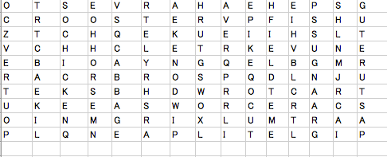

Image 1 B: Locations of Hidden Words

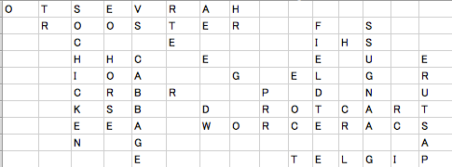

### F. Slider Puzzle

|  |  |  |  |  |  |
| --- | --- | --- | --- | --- | --- |
| **Test Case Number** | **Requirement Number(s)** | **Test Description** | **Expected Result** | **Actual Result** | **Pass/Fail** |
| 1 |  | Startup of application | Display GUI. | GUI is displayed without errors. | Pass |
|  |  |  |  |  |  |
| 2 | 8 | Select a new puzzle. | Display a new puzzle. | New puzzle displayed without errors. | Pass |
|  |  |  |  |  |  |
| 3 | 8 | Select two images on the puzzle to swap until the puzzle is complete. | Once selected, the images swap. Repeat until puzzle is complete. | Once selected, the two images swap. Able to repeat until puzzle complete. | Pass |
|  |  |  |  |  |  |
| 4 |  | Display a message once the user completes the puzzle. | Message displayed once the user has completed the puzzle. | The message is displayed successfully. | Pass |
|  |  |  |  |  |  |
| 5 | 8 | Select a “puzzle hint” to display the puzzle’s final image. | Once a puzzle hint is selected, display the final image of the puzzle. | The final image of the puzzle is displayed. | Pass |
|  |  |  |  |  |  |
| 6 | 8 | Select a new puzzle. | Display a new puzzle for the user to complete. | A new puzzle is successfully displayed. | Pass |
|  |  |  |  |  |  |
| 7 |  | Exit slider puzzle window to return to main menu. | Once exited, the user is returned to the main menu. | The user is successfully returned to the main menu. | Pass |

## 4.3 Inner Working Details (IWD)

**Between User and GameSuiteGUI**:

The system will provide an interface in which the user can select a game. The system will launch the selected game from that interface. The system will allow the user to return to the main interface at any time and to select a new game.

**Between GameSuiteGUI and Maze:**

The system will have built in maze levels that become progressively larger and features more obstacles. The system will allow the user to maneuver their character through the maze using keys on their keyboard (arrow keys or WASD.) The system will display to the user the time it took to complete the maze if successfully completed and maintain a leaderboard for every level. The system will allow the user to replay a completed maze. The system will allow the player to advance to the new maze

Potential Features:

The system will present obstacles within the maze that the user must avoid. The system may present enemy characters that could pursue the user through the maze.

**Between GameSuiteGUI and Sudoku:**

The system will allow the user to play a game. The user will have the option to choose new game, check the status, and exit the game. The user will be able to select a number into a blank cell. The system will check each number as it is inserted. The system will inform the user that a number is incorrect. The user will be able to have the help on if they choose to do so. The user can make mistakes and continue to play until the full game is solved.

**Between GameSuiteGUI and Word Search:**

The system will allow the user to select a theme for a game. The system will allow the user to select a new game corresponding to the theme. The system will display a grid of letters. The system will display a list of words hidden in the grid. The system will allow the user to optionally mark off words from the list. The system will allow the user to mark on the grid the words that they find. The system will allow the user to submit the puzzle when complete. The system will respond to the user if they were successful or provide the correct solution. The system will allow the user to remove the last mark on the grid. The system will allow the user to remove all marks on the grid.

**Between GameSuiteGUI and Snake:**

The system will provide the user an option to start the game. The system will provide a GUI with a snake enclosed in a rectangle/square. The snake will be in constant motion. The system will provide dots or shapes the user will maneuver the snake to eat. The game will end when the snake consumes itself. The system will allow the user to maneuver the snake using their keyboard. The system will provide an option to reset the game when the game ends.

**Between GameSuiteGUI and Slider Puzzle:**

The system will initially present the user with a new puzzle. The system will provide the user with an image of the solution/original picture as reference. The system will divide that image into twelve scattered tiles. The system will allow the user to slide the tiles to form the original image. The system will allow the user to change the reference image.

## 4.4 Context Diagram

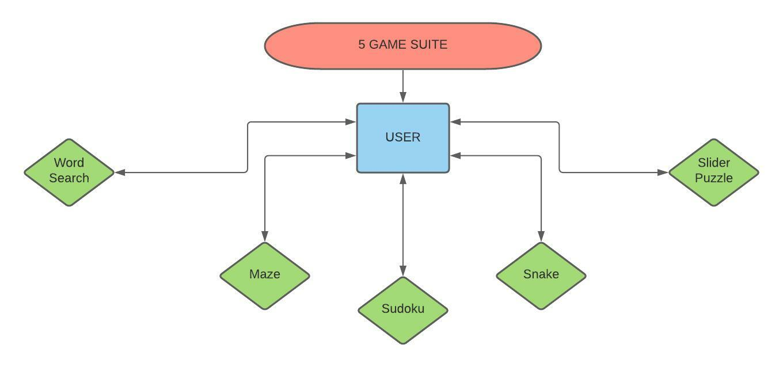

## 4.5 References

*Context diagrams*. Cs.uct.ac.za. (2021). Retrieved 5 September 2021, from https://www.cs.uct.ac.za/mit_notes/software/htmls/ch06s06.html.

# 5. Design and Alternate Designs

## 5.1 Revision History

|  |  |  |  |
| --- | --- | --- | --- |
| **Revision Number** | **Date** | **Description** | **Name** |
| 1 | 9/7 | Creation of Google Doc, outline | Oyewole |
| 2 | 9/11 | Creation of Sequence Diagrams | Jeff |
| 3 | 9/11 | Create Snakes UML diagram and pseudocode | Oyewole |
| 4 | 9/11 | Create Maze and Main menu pseudocode | Wayne |
| 5 | 9/12 | Create Slider UML diagram and pseudocode | Jeff |
| 6 | 9/12 | Create Word search UML diagram and pseudocode | Sherry |
| 7 | 9/12 | Create Sudoku Class Diagram and Code | Janee’ |
| 8 | 9/12 | Create Maze and Main Menu UML | Wayne |
| 9 | 9/12 | Combine all documents into one. Format unified document. Add table of contents. | Sherry |
| 10 | 9/13 | Fixed typos. Fixed formating errors for word search. Adjusted images. Placed pseudcode for programs on separate pages | Sherry |
| 11 | 10/10 | Updated Sudoku pseudocode | Janee’ |

## 5.2 Class Diagram

### Main Menu

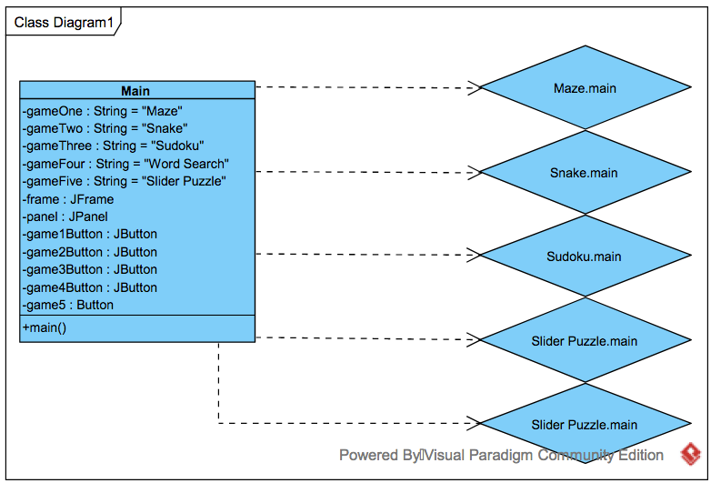

### Maze

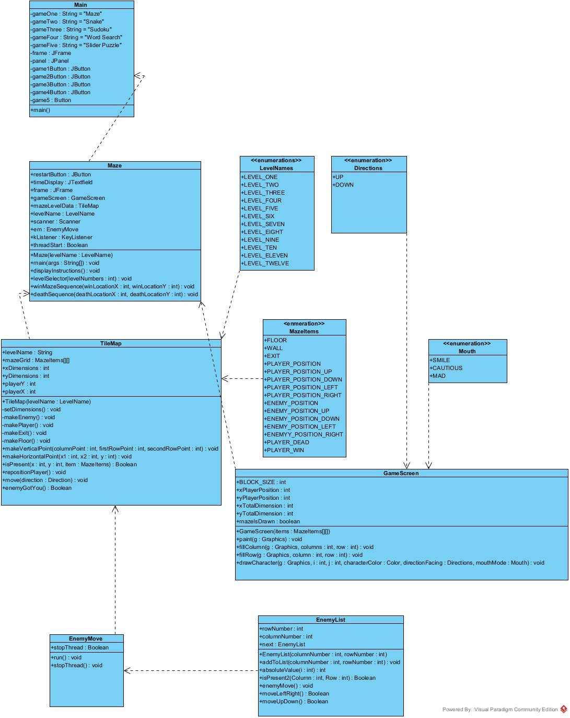

### Snakes

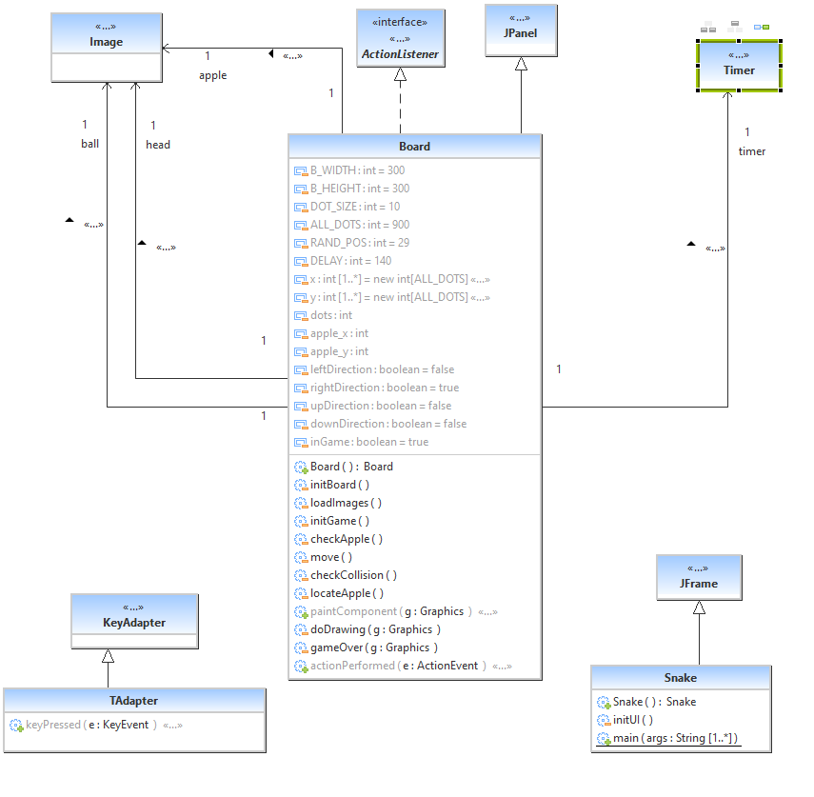

### Sudoku

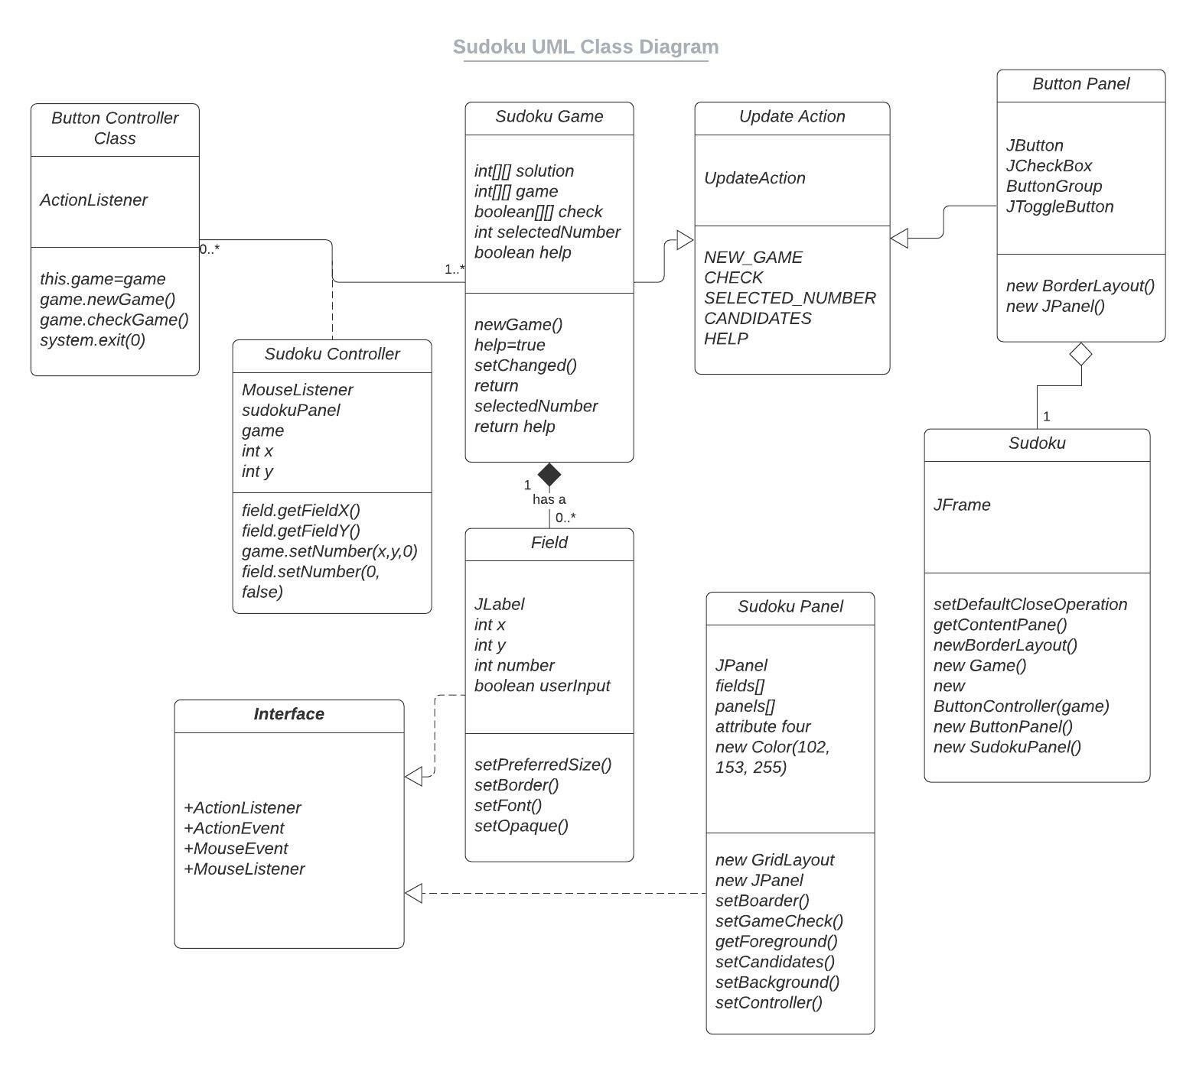

### Word Search

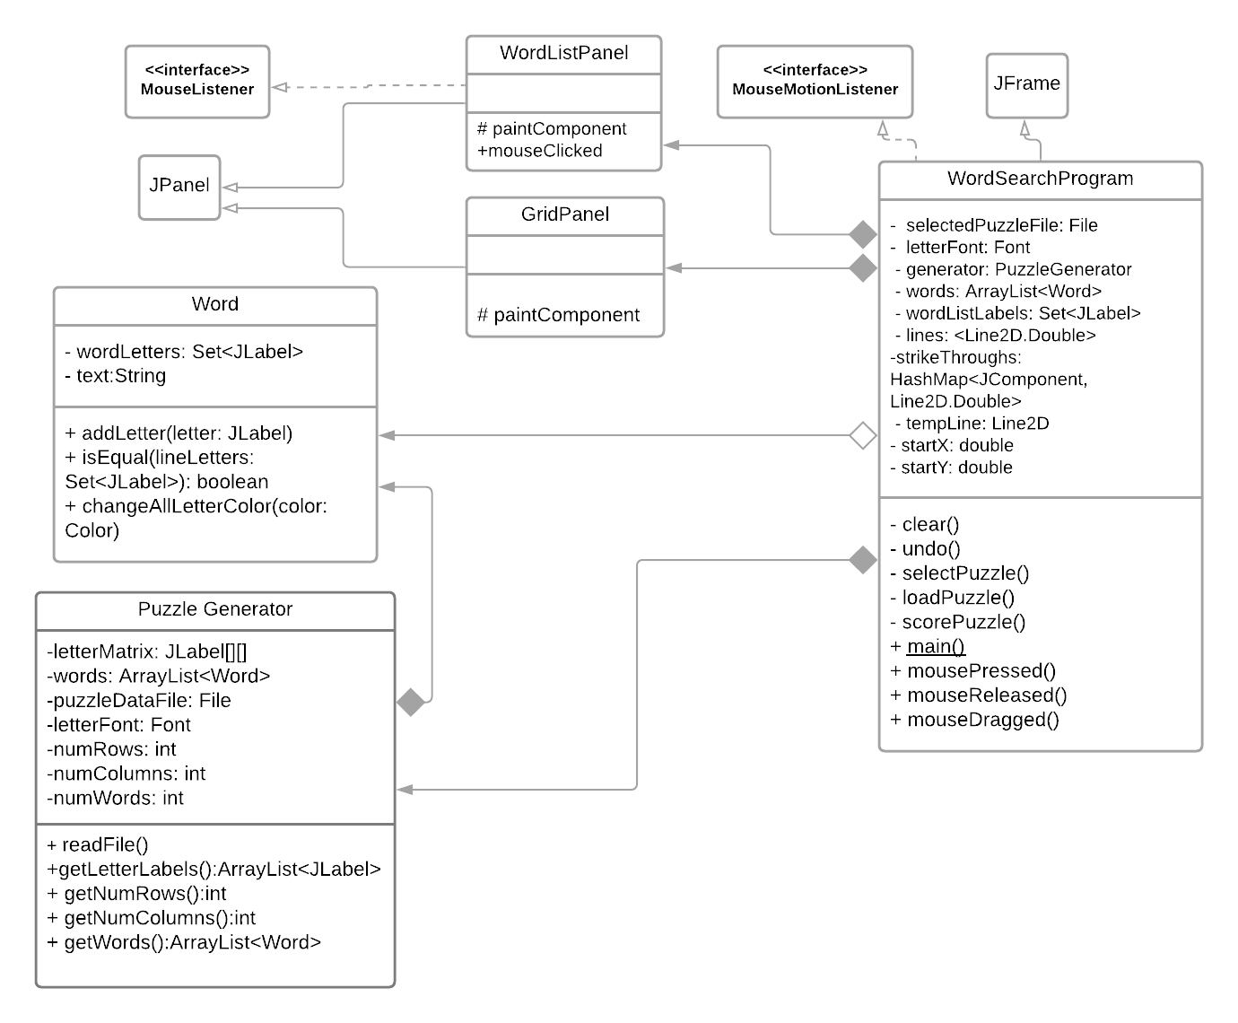

### Slider

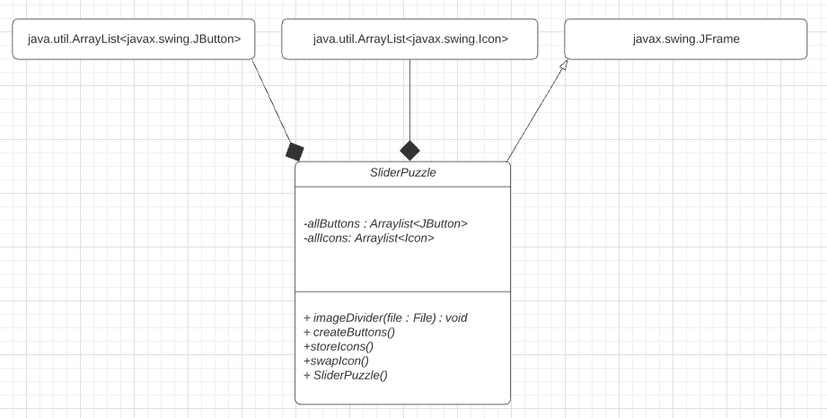

## 5.3 Sequence Diagrams

### Start-up Scenario:

**Description:** User starts up the application.

**Pre-Condition:** No hardware or system failure that would hinder the application occurs.

**Post-Condition**: Application starts without hardware or system failure.

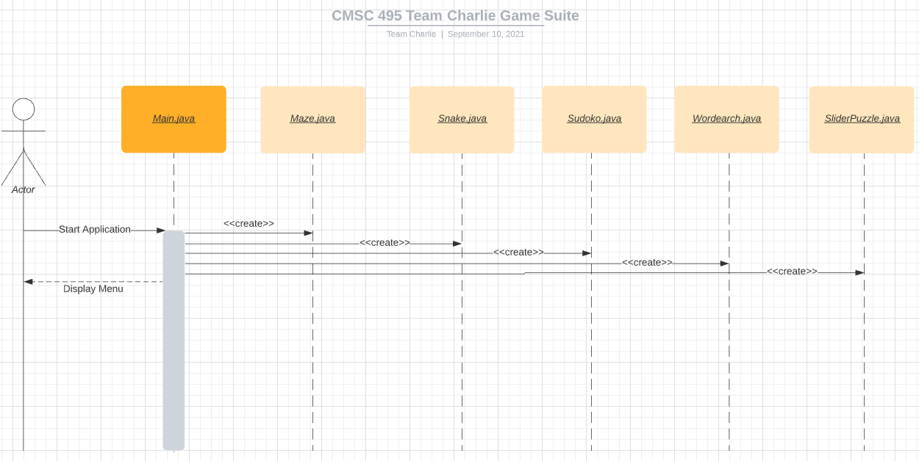

### Shut-down Scenario:

**Description:** User exits the program.

**Pre-Condition:** Program has been running successfully without crashing.

**Post-Condition**: Program is terminated and all objects are deconstructed.

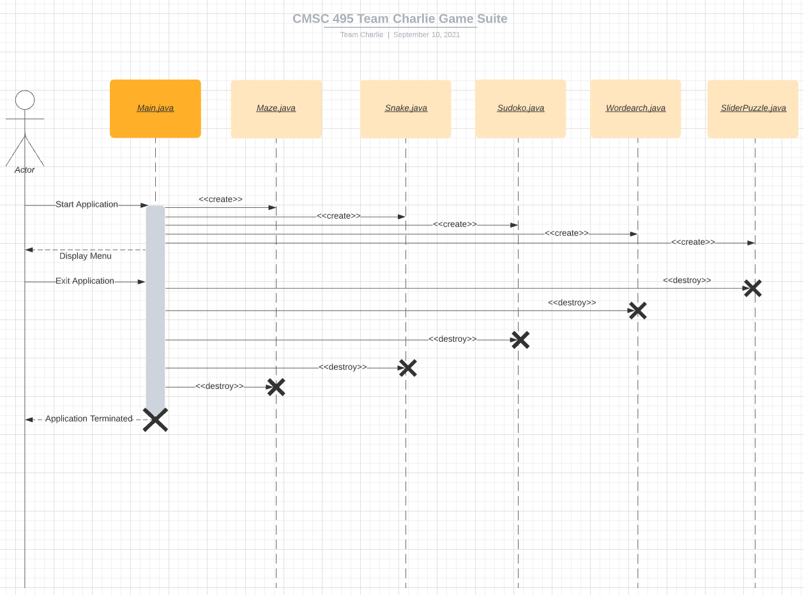

### Normal Operation Scenario:

**Description:** User starts application and selects games from the menu.

**Pre-Condition:** Program has been running successfully.

**Post-Condition**: The program displays and exits each game that has been selected without hardware or system failure.

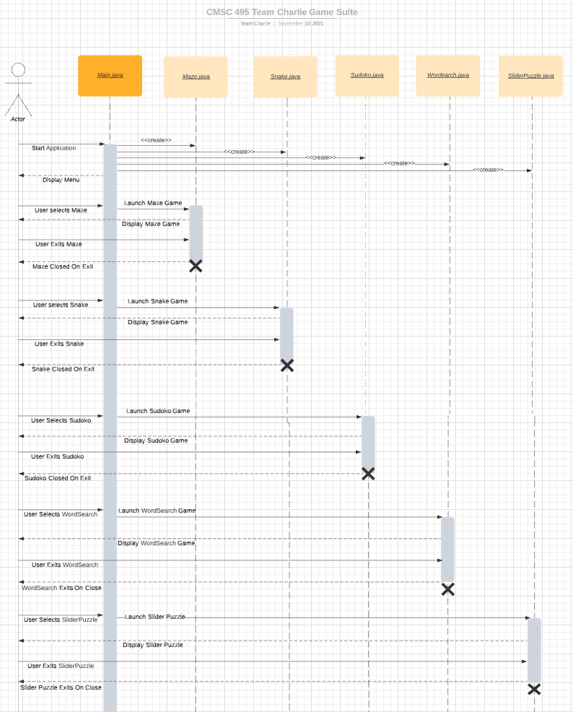

### Error-Handling Scenario 1:

**Description:** User starts application, launches the slider puzzle game, and selects a new puzzle.

**Pre-Condition:** Program has been running successfully.

**Post-Condition**: If a puzzle image file is not found, handle exception, and inform the user with a message:

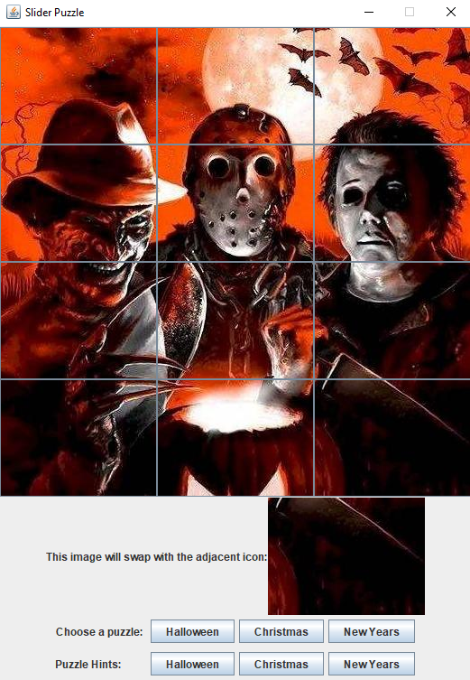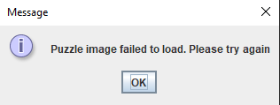

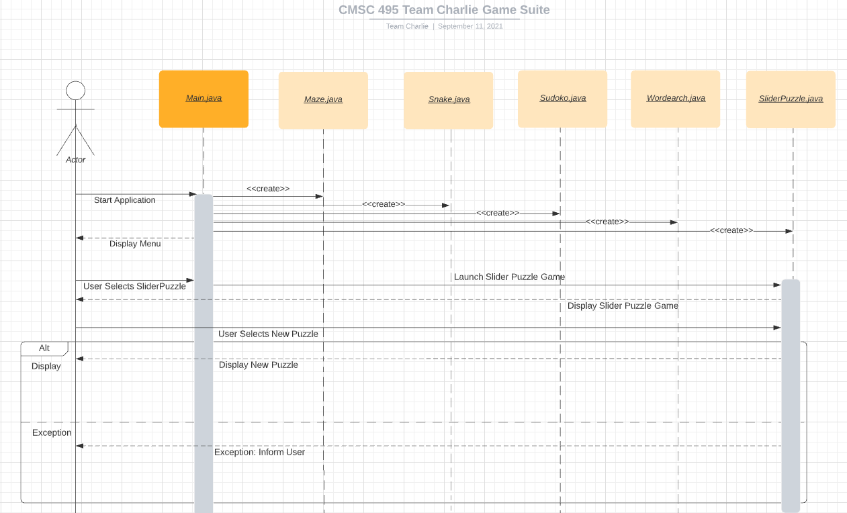

### Error-Handling Scenario 2:

**Description:** User starts application, launches the word search game, and attempts to load a new puzzle file.

**Pre-Condition:** Program has been running successfully.

**Post-Condition**: If a puzzle file fails to load, handle exception, and inform user:

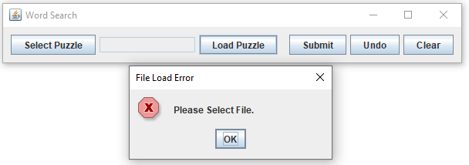

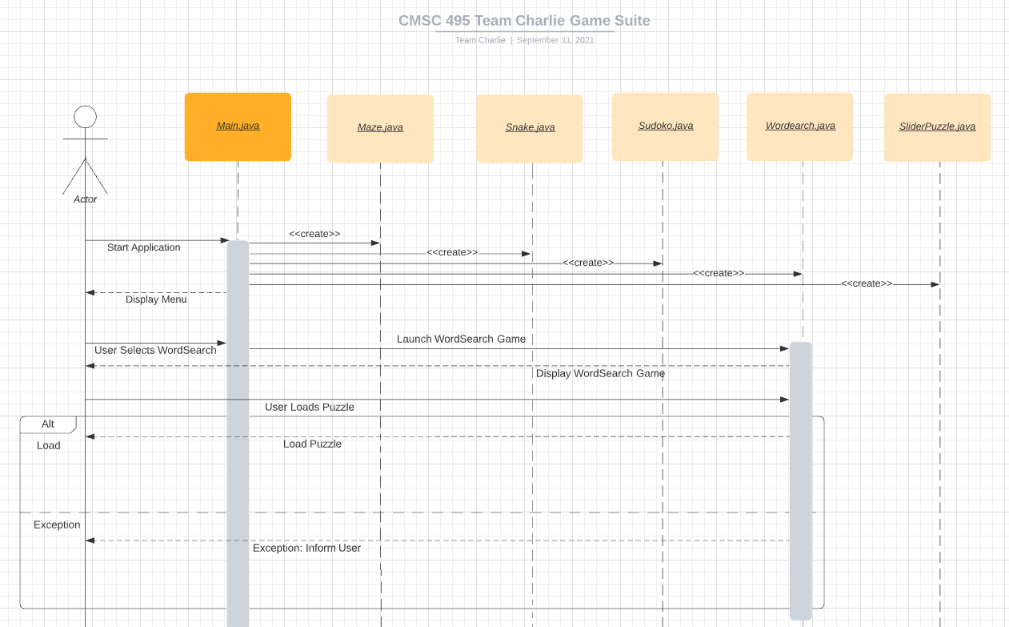

### Error-Handling Scenario 3:

**Description:** User starts application and attempts to load a Sudoku puzzle.

**Pre-Condition:** Program has been running successfully.

**Post-Condition**: If Sudoku fails to load, handle exception, and display a message containing the line number and class name where the exception occurred using .printStackTrace():

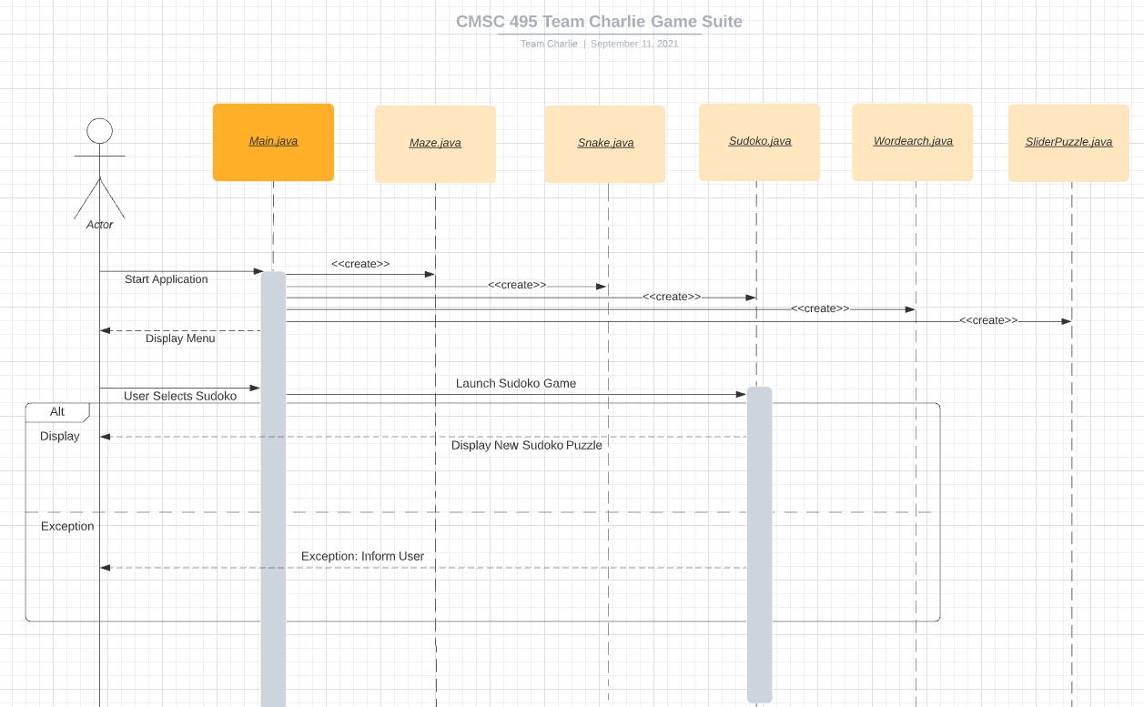

## 5.4 Pseudo Code / Code

### Main Menu:

Build main menu

Ask to select a game

Show buttons for every game

IF Maze is selected

Start Maze Game

IF Snake is selected

Start Snake Game

IF Sudoku is selected

Start Sudoku Game

IF Word Search is selected

Start Word Search Game

If Slider Puzzle is Selected

Start Slider Puzzle

### Maze:

Constructor (LevelNames levelName)

Call LevelName with levelName;

CALL JFrame with Frame("Maze Game");

Make Frame not resizable

CALL TIleMap with mazeLevelData

CALL GameScreen with gameScreen

ADD gameScreen to Frame

SET Frame as Visible

CALL EnemyMove with em

CALL KeyListener with KeyListener

Key is Pressed

If UP key or W is pressed

CALL move in mazeLevelData with argument UP enumeration

If DOWN key of S is Pressed

CALL move in mazeLevelData with argument DOWN enumeration

If LEFT key or A is Pressed

CALL Move in mazeLevelData with argument LEFT enumeration

IF RIGHT key or D is Pressed

CALL Move in mazeLevelData with argument RIGHT enumeration

CALL repaint in gameScreen

START em Thread

main Method

Initialize Menu Screen

IF start button is pressed

Start Maze

IF Instruction button is pressed

Show instructions

If High Score button pressed

Show High scores

win maze Method

Show congratulations screen

Go to next maze

death screen

Encourage player to try again

Restart current maze

Direction enumerations

UP

DOWN

LEFT

RIGHT

Level Name Enumerations

Level 1

Level 2 . . .

Level 12

Maze Items Enumeration

WALL

FLOOR

PLAYER

ENEMIES

EXIT

TIle Map

Constructor

Build Maze Grid according to level number

Set Dimensions of Maze according to grid width

Calculate width

Make Enemy (arguments X and y Coordinates)

Add enemy to grid using X and Y coordinates

Make Player

Add player start point

Make Exit

Add Exit to grid

Make Floor

Add Floor to grid

Make Vertical Path

FOR each grid place in path

CALL make Floor for given point

Make Horizontal Path

For each grid place in path

CALL Make Floor for given Point

Boolean isPresent with Arguments Maze Items and X and Y point

return True if Maze item exists for point in grid

Move with arguments Direction

IF UP is Direction and Grid point above is not WALL

Move to grid point

IF DOWN is Direction and Grid point below is not WALL

Move to grid point

IF LEFT is Direction and Grid point to left is not WALL

Move to grid point

IF RIGHT is Direction and Grid point to right is not WALL

Move to Grid Point

Boolean enemyGotYou with arguments x and y coordinate

Return true if enemy coordinate is x and y

GameScreen

Constructor with Argument Maze Level Data for Level

Fill Grid with maze level data

Draw Characters with arguments facing direction, Color and facial expression

Draw characters with all arguments

TitleScreen

Constructor

Make JFrame

Make Start button

Make instruction Button

Make High score button

Enemy Move

Run Thread

While STOP is not called

FOR each Enemy

CALL enemyMove for enemy

enemyMove

IF player is further away Vertically than Horizontally

CALL moveUpDown

IF could not move UP or DOWN

CALL moveLeftRight

ELSE

CALL moveLeftRight

IF cannot move left Right

CALL moveUpDown

moveUPDOWN

IF player is above you

IF no wall is above you

Move up

ELSE if player is below you

IF no wall is below you

Move down

ELSE

Return FALSE

CALL repaint in gameScreen

Return true (if ELSE is not called)

moveLeftRight

IF player is to left of you

IF no wall is to leftyou

Move left

ELSE if player is to right of you

IF no wall is to right ofyou

Move Right

ELSE

Return FALSE

CALL repaint in gameScreen

Return true (if ELSE is not called)

### Snake:

a. Board Subsystem:

class Board extends JPanel implements ActionListener {

//Define constants used in snake game

//The B_WIDTH and B_HEIGHT constants determine the size of the board.

private final int B_WIDTH = 300;

private final int B_HEIGHT = 300;

//DOT_SIZE is the size of the apple and the dot of the snake.

private final int DOT_SIZE = 10;

//ALL_DOTS constant defines maximum number of possible dots on board (900 = (300*300)/(10*10)).

private final int ALL_DOTS = 900;

//RAND_POS constant is used to calculate a random position for an apple.

private final int RAND_POS = 29;

//DELAY constant determines the speed of the game.

private final int DELAY = 140;

// Both arrays stores x and y coordinates of all joints of snake.

private final int x[] = new int[ALL_DOTS];

private final int y[] = new int[ALL_DOTS];

}

private void loadImages() {

//The ImageIcon class is used for displaying PNG images.

ImageIcon iid = new ImageIcon("src/resources/dot.png");

ball = iid.getImage();

ImageIcon iia = new ImageIcon("src/resources/apple.png");

apple = iia.getImage();

ImageIcon iih = new ImageIcon("src/resources/head.png");

head = iih.getImage();

}

private void initGame() {

//The initGame() method create the snake, randomly locate an apple on the board, and start the timer.

dots = 3;

for (int z = 0; z < dots; z++) {

x[z] = 50 - z * 10;

y[z] = 50;

}

locateApple();

timer = new Timer(DELAY, this);

timer.start();

}

private void checkApple() {

//If the apple collides with the head, we increase the number of joints of the snake.

if ((x[0] == apple_x) && (y[0] == apple_y)) {

dots++;

locateApple();

}

}

//Moving snake joints up the chain.

for (int z = dots; z > 0; z--) {

x[z] = x[(z - 1)];

y[z] = y[(z - 1)];

}

//Moving snake head to the left.

if (leftDirection) {

x[0] -= DOT_SIZE;

}

//If snake hits one of its joints with head the game is over.

for (int z = dots; z > 0; z--) {

if ((z > 4) && (x[0] == x[z]) && (y[0] == y[z])) {

inGame = false;

}

}

//Game is over if snake hits bottom of the board.

if (y[0] >= B_HEIGHT) {

inGame = false;

}

b. Snake Subsystem:

//This is the main class along with the setResizable() method that affects the insets of JFrame

setResizable(false);

pack();

### Sudoku:

**Button Controller Class:**

**//Class controls the user actions from the ButtonPanel**

public class ButtonController implements ActionListener {

private Game game;

**// Constructor, sets game. @param game Game to be set.**

public ButtonController(Game game) {

this.game = game;

}

**// Performs action after user pressed button. @param e ActionEvent.**

public void actionPerformed(ActionEvent e) {

if (e.getActionCommand().equals("New"))

game.newGame();

else if (e.getActionCommand().equals("Check"))

game.checkGame();

else if (e.getActionCommand().equals("Help on"))

game.setHelp(((JCheckBox)e.getSource()).isSelected());

else

game.setSelectedNumber(Integer.parseInt(e.getActionCommand()));

}

}

**Sudoku Controller Class:**

**//Class controls the user actions from SudokuPanel.**

public class SudokuController implements MouseListener {

private SudokuPanel sudokuPanel; **// Panel to control.**

private Game game; **// Current Sudoku game.**

**//Constructor, sets game. @param game Game to be set.**

public SudokuController(SudokuPanel sudokuPanel, Game game) {

this.sudokuPanel = sudokuPanel;

this.game = game;

}

**//Recovers if user clicked field in game. If so it sets the selected number at clicked position in game and updates clicked field. If user clicked a field and used left mouse button, number at clicked position will be cleared in game and clicked field will be updated. @param e MouseEvent.**

public void mousePressed(MouseEvent e) {

JPanel panel = (JPanel)e.getSource();

Component component = panel.getComponentAt(e.getPoint());

if (component instanceof Field) {

Field field = (Field)component;

int x = field.getFieldX();

int y = field.getFieldY();

if (e.getButton() == MouseEvent.BUTTON1 && (game.getNumber(x, y) == 0 || field.getForeground().equals(Color.BLUE))) {

int number = game.getSelectedNumber();

if (number == -1)

return;

game.setNumber(x, y, number);

field.setNumber(number, true);

} else if (e.getButton() == MouseEvent.BUTTON3 && !field.getForeground().equals(Color.BLACK)) {

game.setNumber(x, y, 0);

field.setNumber(0, false);

}

sudokuPanel.update(game, UpdateAction.CANDIDATES);

}

}

public void mouseClicked(MouseEvent e) { }

public void mouseEntered(MouseEvent e) { }

public void mouseExited(MouseEvent e) { }

public void mouseReleased(MouseEvent e) { }

}

**Sudoku Game Class:**

**//Class represents a Sudoku game. It contains the solution, the user input, the selected number and methods to check the validation of the user input.**

public class Game extends Observable {

private int[][] solution; **// Generated solution.**

private int[][] game; **// Generated game with user input.**

private boolean[][] check; **// Holder for checking validity of game.**

private int selectedNumber; **// Selected number by user.**

private boolean help; **// Help turned on or off.**

**// Constructor**

public Game() {

newGame();

check = new boolean[9][9];

help = true;

}

**//Generates a new Sudoku game. All observers will be notified, update action: new game.**

public void newGame() {

solution = generateSolution(new int[9][9], 0);

game = generateGame(copy(solution));

setChanged();

notifyObservers(UpdateAction.NEW_GAME);

}

**//Checks user input again, the solution and puts it into a check matrix. All observers will be notified, update action: check.**

public void checkGame() {

selectedNumber = 0;

for (int y = 0; y < 9; y++) {

for (int x = 0; x < 9; x++)

check[y][x] = game[y][x] == solution[y][x];

}

setChanged();

notifyObservers(UpdateAction.CHECK);

}

**//Sets help turned on or off. All observers will be notified, update action: help. @param help True for help on, false for help off.**

public void setHelp(boolean help) {

this.help = help;

setChanged();

notifyObservers(UpdateAction.HELP);

}

**// Sets selected number to user input. All observers will be notified, update action: selected number. @param selectedNumber Number selected by user.**

public void setSelectedNumber(int selectedNumber) {

this.selectedNumber = selectedNumber;

setChanged();

notifyObservers(UpdateAction.SELECTED_NUMBER);

}

**//Returns number selected user. @return Number selected by user.**

public int getSelectedNumber() {

return selectedNumber;

}

**//Returns whether help is turned on or off. @return True if help is turned on, false if help is turned off.**

public boolean isHelp() {

return help;

}

**//Returns whether selected number is candidate at given position. @param x X position in game. @param y Y position in game. @return True if selected number on given position is candidate, false otherwise.**

public boolean isSelectedNumberCandidate(int x, int y) {

return game[y][x] == 0 && isPossibleX(game, y, selectedNumber)

&& isPossibleY(game, x, selectedNumber) && isPossibleBlock(game, x, y, selectedNumber);

}

**//Sets given number on given position in the game. @param x, The x position in the game. @param y, The y position in the game. @param number, The number to be set.**

public void setNumber(int x, int y, int number) {

game[y][x] = number;

}

**//Returns number of given position. @param x, X position in game. @param y, Y position in game. @return, Number of given position.**

public int getNumber(int x, int y) {

return game[y][x];

}

**//Returns whether user input is valid of given position. @param x, X position in game. @param y, Y position in game. @return, True if user input of given position is valid, false otherwise.**

public boolean isCheckValid(int x, int y) {

return check[y][x];

}

**//Returns whether given number is candidate on x axis for given game. @param game, Game to check. @param y, Position of x axis to check. @param number, Number to check. @return, True if number is candidate on x axis, false otherwise.**

private boolean isPossibleX(int[][] game, int y, int number) {

for (int x = 0; x < 9; x++) {

if (game[y][x] == number)

return false;

}

return true;

}

**//Returns whether given number is candidate on y axis for given game. @param game, Game to check. @param x, Position of y axis to check. @param number, Number to check. @return, True if number is candidate on y axis, false otherwise.**

private boolean isPossibleY(int[][] game, int x, int number) {

for (int y = 0; y < 9; y++) {

if (game[y][x] == number)

return false;

}

return true;

}

**//Returns whether given number is candidate in block for given game. @param game, Game to check. @param x, Position of number on x axis in game to check. @param y, Position of number on y axis in game to check. @param number, Number to check. @return, True if number is candidate in block, false otherwise.**

private boolean isPossibleBlock(int[][] game, int x, int y, int number) {

int x1 = x < 3 ? 0 : x < 6 ? 3 : 6;

int y1 = y < 3 ? 0 : y < 6 ? 3 : 6;

for (int yy = y1; yy < y1 + 3; yy++) {

for (int xx = x1; xx < x1 + 3; xx++) {

if (game[yy][xx] == number)

return false;

}

}

return true;

}

**//Returns next posible number from list for given position or -1 when list is empty. @param game, Game to check. @param x, X position in game. @param y, Y position in game. @param numbers, List of remaining numbers. @return, Next possible number for position in game or -1 when list is empty.**

private int getNextPossibleNumber(int[][] game, int x, int y, List<Integer> numbers) {

while (numbers.size() > 0) {

int number = numbers.remove(0);

if (isPossibleX(game, y, number) && isPossibleY(game, x, number) && isPossibleBlock(game, x, y, number))

return number;

}

return -1;

}

**// Generates Sudoku game solution. @param game, Game to fill, user should pass 'new int[9][9]'. @param index, Current index, user should pass 0. @return, Sudoku game solution.**

private int[][] generateSolution(int[][] game, int index) {

if (index > 80)

return game;

int x = index % 9;

int y = index / 9;

List<Integer> numbers = new ArrayList<Integer>();

for (int i = 1; i <= 9; i++) numbers.add(i);

Collections.shuffle(numbers);

while (numbers.size() > 0) {

int number = getNextPossibleNumber(game, x, y, numbers);

if (number == -1)

return null;

game[y][x] = number;

int[][] tmpGame = generateSolution(game, index + 1);

if (tmpGame != null)

return tmpGame;

game[y][x] = 0;

}

return null;

}

**//Generates Sudoku game from solution. @param game, Game to be generated, user should pass a solution. @return, Generated Sudoku game.**

private int[][] generateGame(int[][] game) {

List<Integer> positions = new ArrayList<Integer>();

for (int i = 0; i < 81; i++)

positions.add(i);

Collections.shuffle(positions);

return generateGame(game, positions);

}

**//Generates Sudoku game from solution, user should use the other generateGame method. This method simple removes a number at a position. If the game isn't valid after this action, the game will be brought back to previous state. @param game,Game to be generated. @param positions, List of remaining positions to clear. @return, Generated Sudoku game.**

private int[][] generateGame(int[][] game, List<Integer> positions) {

while (positions.size() > 0) {

int position = positions.remove(0);

int x = position % 9;

int y = position / 9;

int temp = game[y][x];

game[y][x] = 0;

if (!isValid(game))

game[y][x] = temp;

}

return game;

}

**// Checks whether given game is valid. @param game, Game to check. @return, True if game is valid, false otherwise.**

private boolean isValid(int[][] game) {

return isValid(game, 0, new int[] { 0 });

}

**//Checks whether given game is valid, user should use the other isValid method. There may only be one solution @param game, Game to check. @param index, Current index to check. @param numberOfSolutions, Number of found solutions. Int[] instead of, int because of pass by reference @return, True if game is valid, false otherwise.**

private boolean isValid(int[][] game, int index, int[] numberOfSolutions) {

if (index > 80)

return ++numberOfSolutions[0] == 1;

int x = index % 9;

int y = index / 9;

if (game[y][x] == 0) {

List<Integer> numbers = new ArrayList<Integer>();

for (int i = 1; i <= 9; i++)

numbers.add(i);

while (numbers.size() > 0) {

int number = getNextPossibleNumber(game, x, y, numbers);

if (number == -1)

break;

game[y][x] = number;

if (!isValid(game, index + 1, numberOfSolutions)) {

game[y][x] = 0;

return false;

}

game[y][x] = 0;

}

} else if (!isValid(game, index + 1, numberOfSolutions))

return false;

return true;

}

**//Copies a game. @param game, Game to be copied. @return, Copy of given game.**

private int[][] copy(int[][] game) {

int[][] copy = new int[9][9];

for (int y = 0; y < 9; y++) {

for (int x = 0; x < 9; x++)

copy[y][x] = game[y][x];

}

return copy;

}

**/\***

**\* Prints given game to console. Used for debug.**

**\***

**\* @param game Game to be printed.**

**\***

**private void print(int[][] game) {**

**System.out.println();**

**for (int y = 0; y < 9; y++) {**

**for (int x = 0; x < 9; x++)**

**System.out.print(" " + game[y][x]);**

**System.out.println();**

**}**

**}*/**

}

**Update Action:**

**// Enumeration used to inform observers what to update.**

public enum UpdateAction {

NEW_GAME,

CHECK,

SELECTED_NUMBER,

CANDIDATES,

HELP

}

**Button Panel Class:**

**//Class draws the button panel and reacts to updates from the model.**

public class ButtonPanel extends JPanel implements Observer {

JButton btnNew, btnCheck; **// Used buttons.**

JCheckBox cbHelp; **// Used check box.**

ButtonGroup bgNumbers; **// Group for grouping the toggle buttons.**

JToggleButton[] btnNumbers; **// Used toggle buttons.**

**//Constructs the panel and arranges all components.**

public ButtonPanel() {

super(new BorderLayout());

JPanel pnlAlign = new JPanel();

pnlAlign.setLayout(new BoxLayout(pnlAlign, BoxLayout.PAGE_AXIS));

add(pnlAlign, BorderLayout.NORTH);

JPanel pnlOptions = new JPanel(new FlowLayout(FlowLayout.LEADING));

pnlOptions.setBorder(BorderFactory.createTitledBorder(" Options "));

pnlAlign.add(pnlOptions);

btnNew = new JButton("New");

btnNew.setFocusable(false);

pnlOptions.add(btnNew);

btnCheck = new JButton("Check");

btnCheck.setFocusable(false);

pnlOptions.add(btnCheck);

JPanel pnlNumbers = new JPanel();

pnlNumbers.setLayout(new BoxLayout(pnlNumbers, BoxLayout.PAGE_AXIS));

pnlNumbers.setBorder(BorderFactory.createTitledBorder(" Numbers "));

pnlAlign.add(pnlNumbers);

JPanel pnlNumbersHelp = new JPanel(new FlowLayout(FlowLayout.LEADING));

pnlNumbers.add(pnlNumbersHelp);

cbHelp = new JCheckBox("Help on", true);

cbHelp.setFocusable(false);

pnlNumbersHelp.add(cbHelp);

JPanel pnlNumbersNumbers = new JPanel(new FlowLayout(FlowLayout.LEADING));

pnlNumbers.add(pnlNumbersNumbers);

bgNumbers = new ButtonGroup();

btnNumbers = new JToggleButton[9];

for (int i = 0; i < 9; i++) {

btnNumbers[i] = new JToggleButton("" + (i + 1));

btnNumbers[i].setPreferredSize(new Dimension(40, 40));

btnNumbers[i].setFocusable(false);

bgNumbers.add(btnNumbers[i]);

pnlNumbersNumbers.add(btnNumbers[i]);

}

}

**// Method called when model sends update notification. @param o, The model. @param arg, The UpdateAction.**

public void update(Observable o, Object arg) {

switch ((UpdateAction)arg) {

case NEW_GAME:

case CHECK:

bgNumbers.clearSelection();

break;

}

}

**//Adds controller to all components. @param buttonController, Controller which controls all user actions.**

public void setController(ButtonController buttonController) {

btnNew.addActionListener(buttonController);

btnCheck.addActionListener(buttonController);

cbHelp.addActionListener(buttonController);

for (int i = 0; i < 9; i++)

btnNumbers[i].addActionListener(buttonController);

}

}

**Field Class:**

**//Class represents a field on the SudokuPanel.**

public class Field extends JLabel {

private int x; // X position in game.

private int y; // Y position in game.

**//Constructs the label and sets x and y positions in game. @param x, X position in game. @param y, Y position in game.**

public Field(int x, int y) {

super("", CENTER);

this.x = x;

this.y = y;

setPreferredSize(new Dimension(40, 40));

setBorder(BorderFactory.createLineBorder(Color.GRAY));

setFont(new Font(Font.DIALOG, Font.PLAIN, 20));

setOpaque(true);

}

**//Sets number and foreground color according to userInput. @param number, Number to be set. @param userInput, Boolean indicating number is user input or not.**

public void setNumber(int number, boolean userInput) {

setForeground(userInput ? Color.BLUE : Color.BLACK);

setText(number > 0 ? number + "" : "");

}

**// Returns x position in game. @return X position in game.**

public int getFieldX() {

return x;

}

**// Return y position in game. @return Y position in game.**

public int getFieldY() {

return y;

}

}

**Sudoku Class:**

**// Main class of program.**

public class Sudoku extends JFrame {

public Sudoku() {

super("Sudoku");

setDefaultCloseOperation(EXIT_ON_CLOSE);

getContentPane().setLayout(new BorderLayout());

Game game = new Game();

ButtonController buttonController = new ButtonController(game);

ButtonPanel buttonPanel = new ButtonPanel();

buttonPanel.setController(buttonController);

add(buttonPanel, BorderLayout.EAST);

SudokuPanel sudokuPanel = new SudokuPanel();

SudokuController sudokuController = new SudokuController(sudokuPanel, game);

sudokuPanel.setGame(game);

sudokuPanel.setController(sudokuController);

add(sudokuPanel, BorderLayout.CENTER);

game.addObserver(buttonPanel);

game.addObserver(sudokuPanel);

pack();

setLocationRelativeTo(null);

setVisible(true);

}

**// Main entry point of program. @param args Command line arguments.**

public static void main(String[] args) {

// Use System Look and Feel

try { UIManager.setLookAndFeel(UIManager.getSystemLookAndFeelClassName()); }

catch (Exception ex) { ex.printStackTrace(); }

new Sudoku();

}

}

**Sudoku Panel Class:**

**//Class draws the sudoku panel and reacts to updates from the model.**

public class SudokuPanel extends JPanel implements Observer {

**// Color constant for candidates.**

private static final Color COLOR_CANDIDATE = new Color(102, 153, 255);

private Field[][] fields; **// Array of fields.**

private JPanel[][] panels; **// Panels holding the fields.**

**//Constructs the panel, adds sub panels and adds fields to these sub panels.**

public SudokuPanel() {

super(new GridLayout(3, 3));

panels = new JPanel[3][3];

for (int y = 0; y < 3; y++) {

for (int x = 0; x < 3; x++) {

panels[y][x] = new JPanel(new GridLayout(3, 3));

panels[y][x].setBorder(BorderFactory.createLineBorder(Color.DARK_GRAY));

add(panels[y][x]);

}

}

fields = new Field[9][9];

for (int y = 0; y < 9; y++) {

for (int x = 0; x < 9; x++) {

fields[y][x] = new Field(x, y);

panels[y / 3][x / 3].add(fields[y][x]);

}

}

}

**//Method called when model sends update notification. @param o, The model. @param arg, The UpdateAction.**

public void update(Observable o, Object arg) {

switch ((UpdateAction)arg) {

case NEW_GAME:

setGame((Game)o);

break;

case CHECK:

setGameCheck((Game)o);

break;

case SELECTED_NUMBER:

case CANDIDATES:

case HELP:

setCandidates((Game)o);

break;

}

}

**//Sets the fields corresponding to given game. @param game, Game to be set.**

public void setGame(Game game) {

for (int y = 0; y < 9; y++) {

for (int x = 0; x < 9; x++) {

fields[y][x].setBackground(Color.WHITE);

fields[y][x].setNumber(game.getNumber(x, y), false);

}

}

}

**// Sets fields validity according to given game. @param game, Current game.**

private void setGameCheck(Game game) {

for (int y = 0; y < 9; y++) {

for (int x = 0; x < 9; x++) {

fields[y][x].setBackground(Color.WHITE);

if (fields[y][x].getForeground().equals(Color.BLUE))

fields[y][x].setBackground(game.isCheckValid(x, y) ? Color.GREEN : Color.RED);

}

}

}

**//Shows the candidates according to given game. @param game, Current game.**

private void setCandidates(Game game) {

for (int y = 0; y < 9; y++) {

for (int x = 0; x < 9; x++) {

fields[y][x].setBackground(Color.WHITE);

if (game.isHelp() && game.isSelectedNumberCandidate(x, y))

fields[y][x].setBackground(COLOR_CANDIDATE);

}

}

}

**//Adds controller to all sub panels. @param sudokuController, Controller which controls all user actions.**

public void setController(SudokuController sudokuController) {

for (int y = 0; y < 3; y++) {

for (int x = 0; x < 3; x++)

panels[y][x].addMouseListener(sudokuController);

}

}

}

### Word Search

//Note that “Set” is a data structure like an array, while “SET” is an assignment instruction

//The data type for “letter” is undefined as this is pseudocode and higher-level. Most likely it will be a Java JComponent.

//This class will create a word object

//The object holds a set of letters and a string of text for the word

CLASS word () {

Set letters

String text

FUNCTION constructor (String wordText)

SET text to wordText

FUNCTION addLetter(letter)

ADD letter to letters

FUNCTION toString

RETURN text

FUNTION isEqual (Set otherLetters)

IF Set difference of letters and otherLetters is zero

return true

ELSE

return false

ENDIF

//changes all the colors of a word’s letters for GUI display

FUNCTION changeAllLetterColor (newColor)

FOR letter in letters

SET letter’s color to newColor

END FOR

}

// Class reads in a data file and generates and formats puzzle data for the GUI program

CLASS PuzzleGenerator (puzzleDataFile, letterFont){

Array[][] letterMatrix

Array Word words

int numRows

int numColumns

int numWords

//creates and returns an ordered array of letters to place on the GUI

FUNCTION getLetterLabels()

Array letterList

FOR each row in letterMatrix

FOR each column in letterMatrix

APPEND letterMatrix(row, column) to end of letterList

END loop

END loop

RETURN letterList;

//returns the number of rows in the word search grid

FUNCTION **g**etNumRows()

RETURN numRows

//returns the number of columns in the word search grid

FUNCTION getNumColumns()

RETURN numColumns

//returns the words hidden in the puzzle

FUNCTION getWords()

RETURN words

//Reads in a Puzzle File and Sets Global Variables

FUNCTION readFile()

String fileLine

int lineCounter

SET lineCounter to 0

FOR each line in puzzleFile

fileLine = current line in the File

//Split line by tabs

CALL Split on fileLine RETURNING Array data

//Read in first row of puzzle file, which has puzzle specifications

IFlineCounter==0

numRows = data[0]

numColumns = data[1]

numWords = data[2]

//create matrix

INIT letterMatrix to Array[numRows][numColumns];

INCREMENT lineCounter

//then add letters to the matrix

ELSE IF lineCounter>0 AND lineCounter<=numRows

FOR each letter in data

SET letterMatrix[lineCounter-1][letter’s index] to letter END LOOP

//Read in the hidden words

//Create word object and add text

ELSE IF (lineCounter>numRows AND

lineCounter<=numRows + numWords)

words.add(**new** Word(data[0]))

INCREMENT lineCounter

//Read in the matrix location of the hidden words' letters

// and add those letters to the word

ELSEIF lineCounter>=numRows + numWords AND

lineCounter<=numRows + numWords+numWords

FORevery two numbers in data

SET row to the first number

SET column to the second number

SET letter to letterMatrix (row, column);

//get the corresponding word from Array

SET word to words[lineCounter-numWords -numRows-1]

CALL word.addLetter with letter

END LOOP

INCREMENT lineCounter

END IF

END LOOP

}

//Class displays the GUI

CLASS WordSearchProgram{

Array lines

Map strikeThroughs

int startX

int startY

puzzleFile

FUNCTION constructor{

Create loadButton

Create select puzzle button

Create clear button

Create undo button

Create field for puzzleFileTitle

Add buttons and fields to GUI

FUNCTION main

Displays GUI on start up

//adds the users’ highlights of letters onto grid and strikethroughs through words on the wordlist

FUNCTION paintComponent

FOR each line in lines

PAINT line

FOR strikethrough in strikeThroughs

PAINT strikethrough

FUNCTION mousePressed()

SET startX to cursor’s x coordinate

SET startY to cursor’s y coordinate

FUNCTION mouseReleased()

double x

double y

SET x to cursor’s x coordinate

SET y to cursor’s y coordinate

Create line from startX, startY, x, y

Add line to lines

SET startX, startY to 0

FUNCTION actionPerformed()

IF undoButton clicked

CALL undo

IF selectButton clicked

CALL selectPuzzle

IF clearButton clicked

CALL clear

IF submitButton clicked

CALL submit

END IF

FUNCTION undo()

Remove last line from lines

Repaint GUI

FUNCTION clear()

Remove all lines from lines

Remove all strikethroughs from strikethroughs

Repaint GUI

FUNCTION selectPuzzle():

CALL file chooser program

SET puzzleFile to file selected from file chooser program

SET puzzleTitleField to puzzle file’s name

FUNCTION loadPuzzle():

INIT generator with puzzle file

CALL generator.readFile()

SET letters to generator.getLetterLabels

SET words to generator.getWords

FOR each word in words

Add word text to wordlist display on GUI

END LOOP

FOR each letter in letters

Add letter to letter display on GUI

END LOOP

REPAINT GUI

//adds or removes a strikethrough from a word on the word list

FUNCTION mouseClicked()

IF mouse clicked on word in wordlist display on GUI

IF word in strikeThroughs

Remove word from strikeThroughs

ELSE

Create line through word coordinates

ADD word and line through word to strikeThroughs

END IF

ENDIF

FUNCTION scorePuzzle();

//First get the total number of words in the puzzle

SET numWords to length of words

FOR each line in lines

Set lineLetters

FOR each letter in letters

IF line intersects letter

add letter to lineLetters

ENDIF

END LOOP

FOR each word in words

IF words.isEquals(lineLetters) RETURNS True

//words intersecting line match actual word

Remove word from words

ENDIF

END LOOP

SET numFoundWords to numWords – length of words

DISPLAY numFoundWords on GUI

//Change color of all unfound words on GUI

FOR word in words:

CALL word.changeAllLetterColor(Red)

Repaint GUI

}

### Slider Puzzle

public class SliderPuzzle extends JFrame {

Initialize "allicons" as new arraylist to store icons

Initialize "allButtons" as new arraylist to store buttons

// Constructor for SliderPuzzle class

public SliderPuzzle(){

// call method that splits the main image into 12 jpg files

imageDivider(new File("PuzzleName.jpg"));

// call method that stores icons

storeButtons();

//call method that creates buttons

createButtons();

//Initialize 11 image icons that will be used as tiles

Icon image1 through image12 = new ImageIcon("TileName.jpg");

// Initialize final image icons that will be used for hints

Icon finalPictureIcon0 = new ImageIcon("Puzzle1.jpg");

Icon finalPictureIcon1 = new ImageIcon("Puzzle2.jpg");

Icon finalPictureIcon2 = new ImageIcon("Puzzle3.jpg");

// Create main and sub panels that will be added to frame

JPanel backGroundPanel = new JPanel();

JPanel subPanel = new JPanel();

JPanel mainPanel = new JPanel();

JPanel puzzleChooserPanel = new JPanel();

JPanel finalImageSubPanel = new JPanel();

// Create JButtons that will display image icons to form puzzle

JButton jButton1 through jButton12 = new JButton(image1 through 12);

// JLabel used for choosing puzzle

JLabel newPuzzleJLabel = new JLabel("Choose a Puzzle");

// JButtons for choosing new puzzle

JButton newPuzzleButton1 = new JButton("Puzzle 1");

JButton newPuzzleButton2 = new JButton("Puzzle 2");

JButton newPuzzleButton3 = new JButton("Puzzle 3");

// JLabel and JButtons that displays puzzle hints when selected

JLabel finalPictureLabel = new JLabel("Puzzle Hints:");

JButton finalImageJButton = new JButton("Final Image 1");

JButton finalImageJButton1 = new JButton("Final Image 2");

JButton finalImageJButton2 = new JButton("Final Image 3");

// JLabels used to show which icon has the power to swap with adjacent icon

JLabel jLabelPowerIcon = new JLabel(image12);

JLabel powerIconDefinitionLabel = new JLabel("This image will swap with the adjacent icon:");

// Set layouts for panels

subPanel.setLayout(new BoxLayout(subPanel, BoxLayout.X_AXIS));

backGroundPanel.setLayout(new BoxLayout(backGroundPanel, BoxLayout.Y_AXIS));

mainPanel.setPreferredSize(new Dimension(524, 522));

mainPanel.setLayout(new GridLayout(4,3,0,0));

setSize(new Dimension(524,522));

// Add image tiles to main panel

mainpanel.add(jButton1 through jButton12);

// Add power icon definition labels

subPanel.add(powerIconDefinitionLabel);

subPanel.add(jLabelPowerIcon);

// Add JLabel and JButtons to puzzle chooser panel

puzzleChooserPanel.add(newPuzzleJLabel);

puzzleChooserPanel.add(newPuzzleButton1);

puzzleChooserPanel.add(newPuzzleButton2);

puzzleChooserPanel.add(newPuzzleButton3);

// Add JLabel and JButtons to final image sub panel

finalImageSubPanel.add(finalPictureLabel);

finalImageSubPanel.add(finalImageJButton);

finalImageSubPanel.add(finalImageJButton1);

finalImageSubPanel.add(finalImageJButton2);

// Add panels

backGroundPanel.add(mainPanel);

backGroundPanel.add(subPanel);

backGroundPanel.add(puzzleChooserPanel);

backGroundPanel.add(finalImageSubPanel);

add(backGroundPanel);

}

// Add action listeners to puzzle hint JButtons

finalImageJButton.addActionListener(new ActionListener() {

@Override

public void actionPerformed(ActionEvent e) {

JOptionPane.showMessageDialog(null,"", "Hint",

JOptionPane.INFORMATION_MESSAGE, finalPictureIcon0);

}

}) ;

finalImageJButton1.addActionListener(new ActionListener() {

@Override

public void actionPerformed(ActionEvent e) {

JOptionPane.showMessageDialog(null,"","Hint",

JOptionPane.INFORMATION_MESSAGE, finalPictureIcon1);

}

});

finalImageJButton2.addActionListener(new ActionListener() {

@Override

public void actionPerformed(ActionEvent e) {

JOptionPane.showMessageDialog(null,"","Hint",

JOptionPane.INFORMATION_MESSAGE, finalPictureIcon2);

}

});

pack();

setResizable(false);

setLocationRelativeTo(null);

setVisible(true);

/**

* Stores all icons for puzzle in an arraylist

*/

public void storeIcons(){

for(int i = 0; i < 12; i++){

Icon icon = new ImageIcon("Name" + i + ".jpg");

allIcons.add(icon);

}

}

/**

* Generates 12 JButtons

*/

public void createButtons(){

for (int i = 0; i < 12; i++){

new JButton(allIcons.get(i));

}

Collections.shuffle(allIcons);

for(int j = 0; j < 12; j++){

mainPanel.add(allButtons.get(j));

}

}

/**

* Splits the complete image into separate tiles

* @param file to split

*/

public void imageDivider(File file) {

try {

FileInputStream fileInputStream = new FileInputStream(file);

BufferedImage image = ImageIO.read(fileInputStream);

int rows = 4;

int cols = 3;

int tiles = rows * cols;

// Calculate tile width and height

int tileWidth = image.getWidth() / cols;

int tileHeight = image.getHeight() / rows;

int count = 0;

// This array stores the image tiles

BufferedImage images[] = new BufferedImage[tiles];

for (int x = 0; x < rows; x++) {

for (int y = 0; y < cols; y++) {

images[count] = new BufferedImage(tileWidth, tileHeight, image.getType());

Graphics2D gr = images[count++].createGraphics();

gr.drawImage(image, 0, 0, tileWidth, tileHeight, tileWidth * y, tileHeight * x,

tileWidth * y + tileWidth, tileHeight * x + tileHeight, null);

gr.dispose();

}

}

// Create new files for each puzzle piece 1 through 12

for (int i = 0; i < images.length; i++) {

ImageIO.write(images[i], "jpg", new File("Puzzle Piece Names" + i + ".jpg"));

}

// Display message if file is not found in the working directory

} catch (IOException e) {

JOptionPane.showMessageDialog(null, e.getMessage());

}

}

public static void main(String[] args) {

ImagePuzzle imagePuzzle = new ImagePuzzle();

imagePuzzle.setDefaultCloseOperation(EXIT_ON_CLOSE);

}

}

## 

## 5.5 References

“Bi-directional and uni-directional associations UML.” (2017, Sept). Stack Overflow. Retrieved September 12, 2021 from

https://stackoverflow.com/questions/15487372/bi-directional-and-uni-directional-associations-uml

Creately. (2021). Sequence diagram tutorial – complete guide with examples. Retrieved from

https://creately.com/blog/diagrams/sequence-diagram-tutorial/

Dalby, J. (2003, February 21). Pseudocode Standard. Cal Poly Computer Science & Software Engineering. Retrieved September 10, 2021 from “https://users.csc.calpoly.edu/~jdalbey/SWE/pdl_std.html

IBM. (n.d.). “Aggregation Relationships.” Rational Software Architect 9.5. Retrieved from <https://www.ibm.com/docs/en/rational-soft-arch/9.5?topic=diagrams-aggregation-relationships>

University of Washington Computer Science and Engineering. (2011). *Design and UML Class Diagrams*. The University of Washington. Retrieved September 9, 2021 from <https://courses.cs.washington.edu/courses/cse403/11sp/lectures/lecture08-uml1.pdf>

# 6. Development History

## 6.1 Revision History

|  |  |  |  |
| --- | --- | --- | --- |
| **Revision Number** | **Date** | **Description** | **Name** |
| 1 | 9/13 | Creation of Doc and Outline | Oyewole |
| 2 | 9/13 | Overview and Milestone | Oyewole |
| 3 | 9/13 | Phase 1 created/ Modified | Oyewole |
| 4 | 9/19 | Modified Phase 1. Added Phase 2-4 Projected Milestones/Schedule | Sherry |
| 5 | 9/19 | Created Phase 1 Description for Sudoku | Janee’ |
| 6 | 9/19 | Created Phase 1 write up for Word Search | Sherry |
| 7 | 9/19 | Phase 1 documentation for Slider Puzzle | Jeff |
| 8 | 9/19 | Phase 1 Summary Maze | Wayne |
| 9 | 9/19 | Phase 1 documentation for Snakes game | Oyewole |
| 10 | 9/19 | Combined and formated individual files into a unified document. Add table of contents. | Sherry |
| 11 | 9/20 | Add screen capture for maze | Wayne |
| 12 | 9/20 | Formatting, updating page numbers, editing typos etc. | Sherry |
| 13 | 9/20-21 | Review | Oyewole, Janee’, Wayne, Jeff, Sherry |

Phase 2:

|  |  |  |  |
| --- | --- | --- | --- |
| **Revision Number** | **Date** | **Description** | **Name** |
| 1 | 9/22 | Creation of Phase 2 Doc and Outline | Oyewole |
| 2 | 9/23 | Phase 2 Overview and Milestone | Oyewole |
| 3 | 9/23 | Phase 2 created/ Modified | Oyewole |
| 4 | 9/26 | Slider Puzzle Phase 2 Description | Jeff |
| 5 | 9/26 | Phase 2 Documenation for Sudoku | Janee’ |
| 6 | 9/26 | Phase 2 Documentation for Word Search | Sherry |
| 7 | 9/26 | Phase 2 Maze | Wayne |
| 8 | 9/26 | Phase 2 Snakes | Oyewole |
| 9 | 9/26 | Combine Files, Formatting, Add Table of Contents | Sherry |
| 10 | 9/28 | Minor Edits Maze Game | Wayne, Sherry |

Phase 3:

|  |  |  |  |
| --- | --- | --- | --- |
| **Revision Number** | **Date** | **Description** | **Name** |
| 1 | 9/22 | Phase 3 :Creation of Doc and Outline | Oyewole |
| 2 | 9/23 | Phase 3: Overview and Milestone | Oyewole |
| 3 | 9/23 | Phase 3 created/ Modified | Oyewole |
| 4 | 10/3 | Updated Phase 4 Goals | Sherry |
| 5 | 10/3 | Phase 3 Documentation Snakes | Oyewole |
| 6 | 10/3 | Word Search and Main Menu Phase 3 Writeup | Sherry |
| 7 | 10/3 | Slider Puzzle Phase 3 Description | Jeff |
| 8 | 10/3 | Phase 3 Sudoku | Janee’ |
| 9 | 10/3 | Combine and format files. Add Table of Contents | Sherry |
| 10 | 10/4 | Maze Phase 3 | Wayne |

Phase 4:

|  |  |  |  |
| --- | --- | --- | --- |
| Revision Number | Date | Description | Name |
| 1 | 10/9 | Creation of Doc and Outline | Oyewole |
| 2 | 10/9 | Overview and Milestone | Oyewole |
| 3 | 10/9 | Phase 4 created/ Modified | Oyewole |
| 4 | 10/9 | Testing Description | Sherry, Jeff |
| 5 | 10/9 | Snakes and Conclusion | Oyewole |
| 6 | 10/9 | Lessons Learned | Wayne |
| 7 | 10/9 | Sudoku and Conclusion | Janee’ |
| 8 | 10/9 | Word Search and Conclusion | Sherry |
| 9 | 10/9 | Conclusion | Jeff |
| 10 | 10/9 | Combine all phase 4 documents. Combine and format all documents into one file. Edit and create consistent formatting. Add results test plan. Wrote overview for conclusion. | Sherry |
| 11 | 10/9 | Editing | Janee’ |
| 12 | 10/10 | Editing | Sherry |

## 6.2 Team Milestones

The following table shows our goals and their completion status for the four development phases.

|  |  |  |  |
| --- | --- | --- | --- |
|  | Projected Date of  Accomplished Goal | Name of the Goal | Was the Goal  Accomplished |
| Phase 1 | 9/13 | Design what the system does and how the different pieces fit together. | Yes |
| 9/20 | Start GUI coding | Yes |
| 9/20 | Start other required classes coding | Yes |
| Phase 2 | 9/26 | Continue GUI and other required classes coding | Yes |
| 9/26 | Finish and share prototypes of working games with group | Yes |
| 9/26 | Start Testing | Yes |
| Phase 3 | 10/1 | Integrate all games and main menu into package | Yes |
| 10/1 | Testing | Yes |
| 10/3 | Revise code and implement additional features | Yes |
| Phase 4 | Final Sprint and Delivery | | |
| 10/6 | Testing | Yes |
| 10/6 | Finishing Touches | Yes |
| 10/6 | Update all documents with any changes | Yes |
| 10/8 | Group Revision | Yes |

## 6.3 Phase 1 Report

### A. Maze

The maze game has many of its data structures and algorithms built and operational. The main menu was built but is currently incomplete and only runs the game. The game runs in beta displaying only one complete level and repeating it to test out the algorithm. The graphics programming, the data structure for the maze grid, and the logic with the enemies movements have been completed.

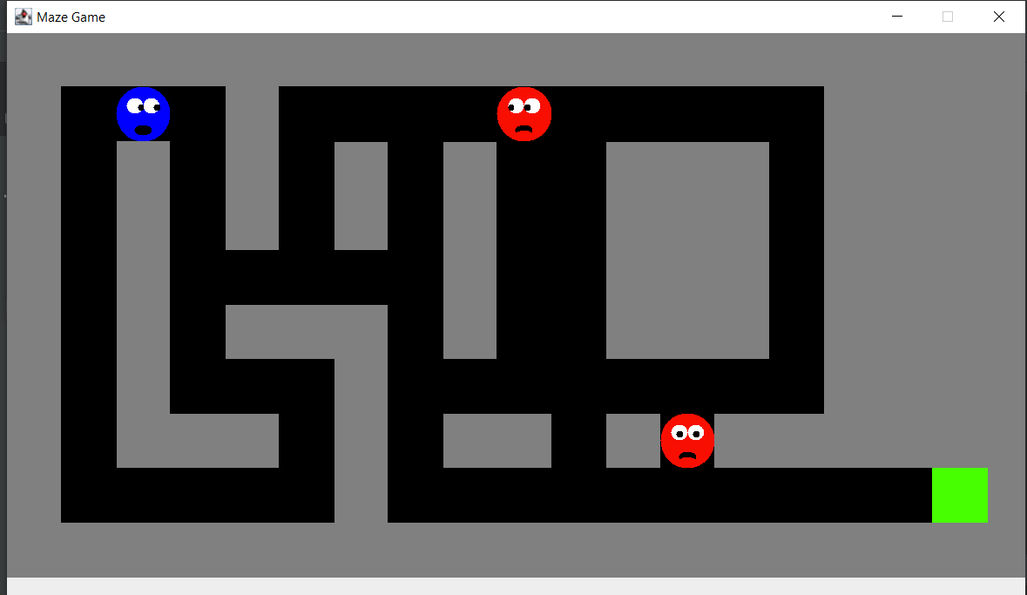

What now remains is the remaining levels and the coding for the leaderboard. The current iteration of the game allows the player to play and complete a level. All remaining functionality is currently under development

### B. Snakes

I’ve completed phase 1 to include all of my design plans, which includes the GUI and algorithm for the snake movements. Our main java code enables us to launch games quickly via the gui interface. Refer to figure 1.1.

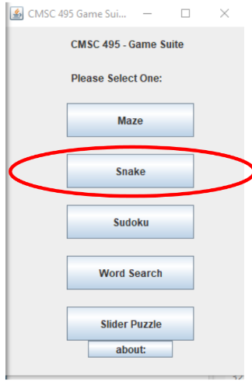 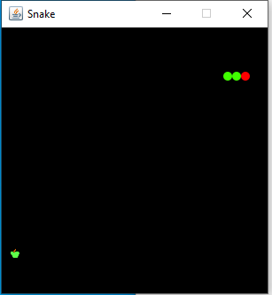

Figure 1.1

I’m currently modifying speeds to see which setting best fits the tempo of the game. I’ve also programed the maneuvering keys so players can take control of the snake. Next steps will include coding an out of bounds feature that players cannot cross and will trigger an automatic game over if crossed. Refer to figure 1.2.

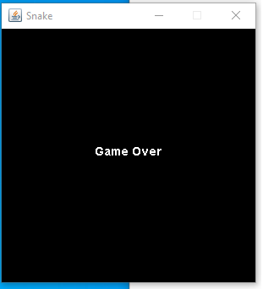

Figure 1.2

### C. Sudoku

At the beginning of the creation of the Sudoku puzzle for the game suite, the idea was to create three Sudoku puzzles all with a different difficulty level labeled Beginner, Intermediate, and Advanced. The user would be able to go through the main menu, choose Sudoku, then use another menu to choose the difficulty of their choice. Going through it seemed as if it could be done, but trying to keep the simplistic nature, I decided to just create one difficulty level and have various games. The errors or issues that I came about with the three different difficulty levels was having to create another menu within the Sudoku puzzle itself. The layout was there, but the coding was giving me trouble. I gave it about a week to see if I could get something to produce from it, but I kept receiving the same error. Through using Stack Overflow for research options and to gain the knowledge of how to configure a working product, it turned out to be a dead end.

Moving forward, the product being produced is the Sudoku game with one difficulty level, across various games. The user can start a new game, check their progress, and exit. Once they complete the game, clicking exit will take them to the main menu so that a new game can be chosen. Creating the code for this version of the game did not generate too many errors, but there still were some. The Sudoku game was broken down into three separate packages: controller, model, and view. This made the layout more simplistic and where and what needed to be done for the final solution. The controller package would allow the member to choose the button control and sudoku puzzle controls. The button controls display to the user options to select a new game, check a game, and exit a game. The sudoku puzzle controls display to the user the numbers as well as the help. The user can choose if they would like the help on or not. If the help is on, then it will display a blue background once the number is chosen. This shows the user the number chosen goes in the appropriate boxes. The model package would entail the game code and the action code. The game code would let the user know that the numbers 1-9 would only be allowed in each 3x3 block, as well as in each horizontal and vertical line. No numbers would be able to repeat and each block will hold the correct number chosen. Using the check button, the user will be able to check to make sure that the numbers are being inputted into the appropriate box. Lastly, the view package holds the main class, which is the Sudoku class, the button panel, the field, and the sudoku panel. The view package brings everything together that is run from the Sudoku class.

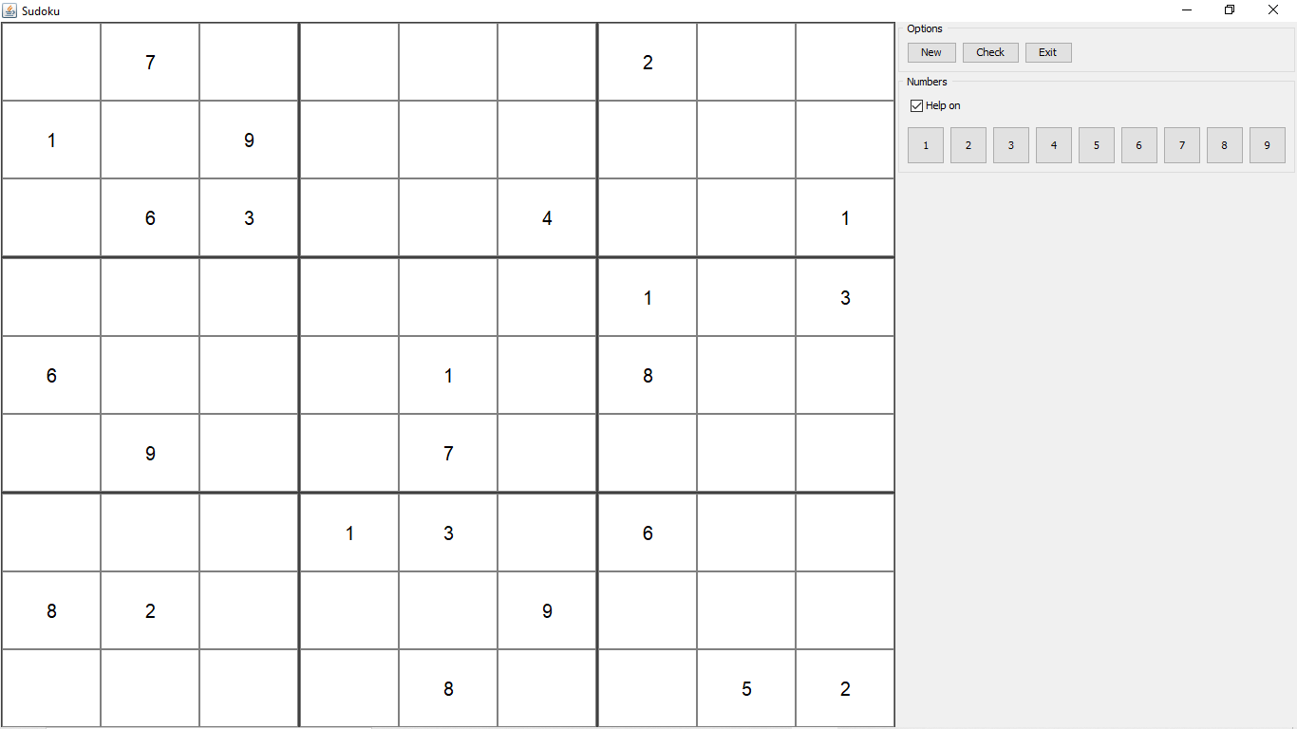

Figure 1: User is presented once Sudoku is chosen from the main menu.

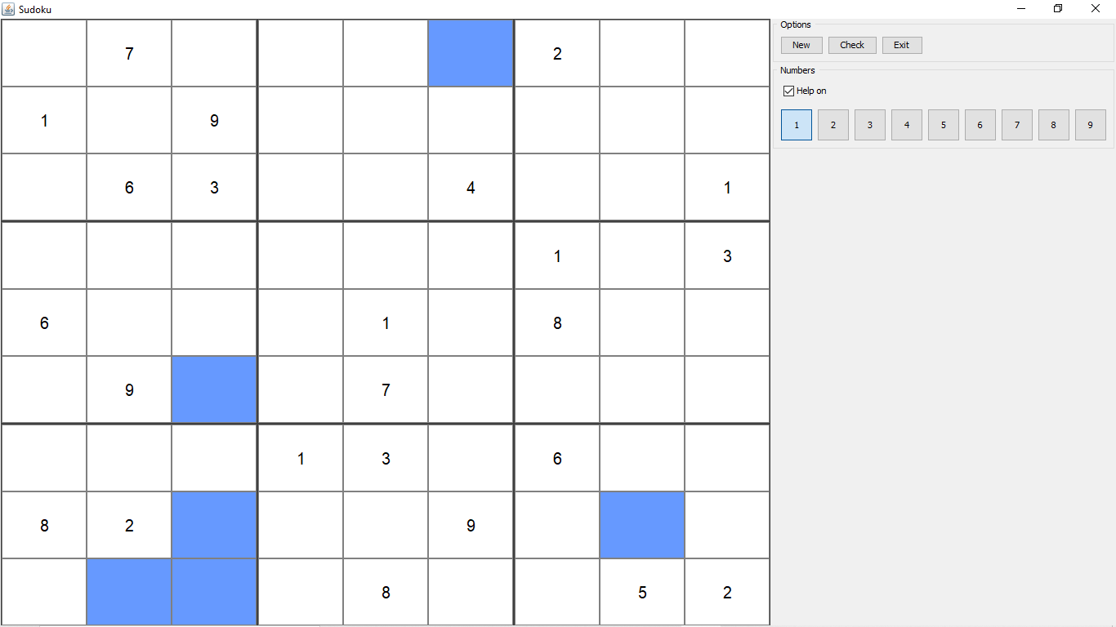

Figure 2: User selects number, with the help on, shows where that number belongs.

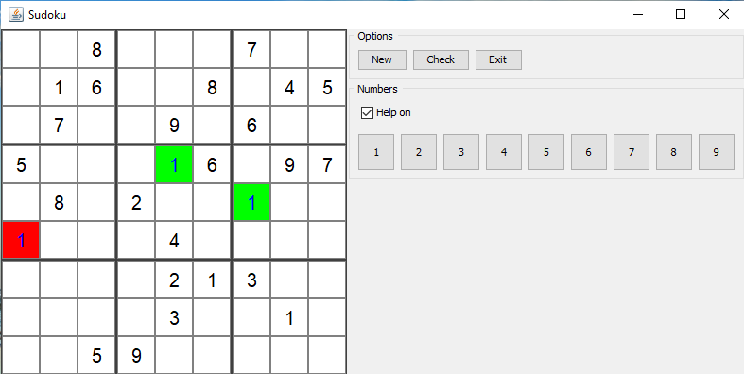

Figure 3: User checks progress, Green annotates that number is entered in correct block, Red annotates that number is incorrectly entered in block.

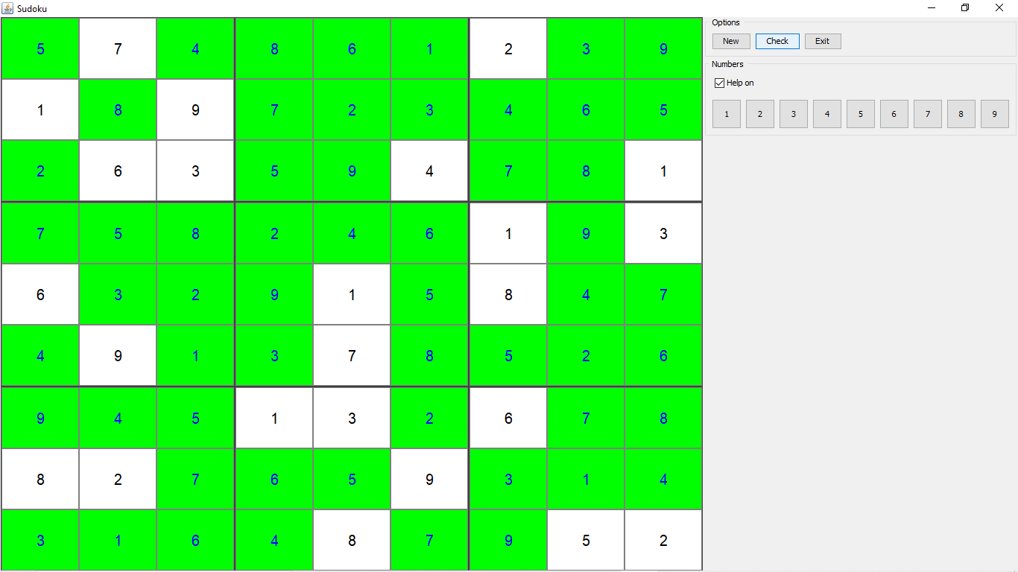

Figure 4: User has completed the game. User can select New Game to play again (new game board generated) or Exit Game to be directed to the main menu.

### D. Word Search

The primary goal for the word search program’s first development phase was to add functionality to the mock-up GUI that was created for the user guide. This goal was successfully achieved and overall my implementation was consistent with plans indicated in the user guide and design plan. The first hurdle was to settle on how to display the letters on the word search grid so that the program could determine if highlighted letters matched a word on the word list. I considered two options: using Java2D graphics and creating TextLayout objects or using JLabels and a JPanel with a GridLayout. The benefit of former was that I could potentially do hit testing on individual letters. However, creating my own grid in a modified coordinate system with the letters evenly spaced in the desired manner, especially if the size of the puzzle changed, proved challenging. I tested and opted for the latter approach.

Next, I implemented and tested the system’s ability to recognize highlighted words. I made a design decision that only a continuous full stroke of the cursor over the center of a word’s letters would be a valid highlight. To determine if a line went through a letter I iterated through an ArrayList containing all the JLabels displaying letters on the grid. I determined that if I centered the text in a JLabel, calculated the center of the label, and drew a Rectangle2D object around the text, I could see if a line intersected the letter. Using set operations I determined if a set of letters for a word were exactly the same as those that were intesected by a line.

The next functionality that I tackled was modifying the word list so that when the user clicks on word a strikethrough will be drawn through it and when unclicked the line would be removed. I opted here to use JLabels to hold the text and calculated the length and position of the line to be drawn through the text by using FontMetrics to measure the length of the text in the label. I used a HashMap to store the line associated with a JLabel so it could be easily be located and removed if clicked.

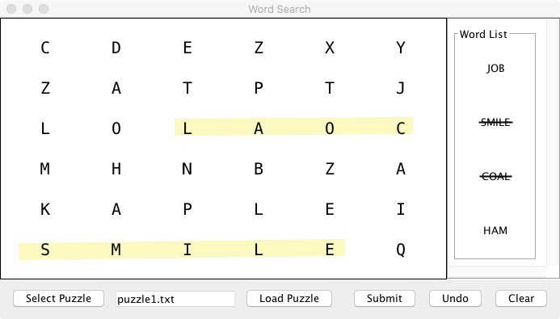

Figure A. Implementation of highlights and strikethroughs

Lastly, I added basic functionality to the JButtons. First I determined having the user select a puzzle from a drop down menu as specified in the user guide would be problematic if games are added or removed in the future. Instead of opting for a configuration file to create the list of games which would have to be updated every time a game changed, I decided to use Java’s JFileChooser and have the user select a game from a specific puzzle file directory. This involved changing the display and adding a warning if the user tries to submit an empty file. I will update the user guide and test plan to reflect these changes and test that the user cannot access files from other directories. I also implemented the clear button to remove all lines and strikethroughs from the board and word list and the undo button to only remove highlights from the grid.

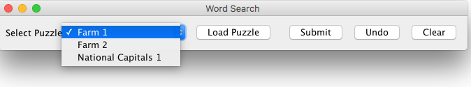

Figure B. Original selection of puzzle from a drop down list.

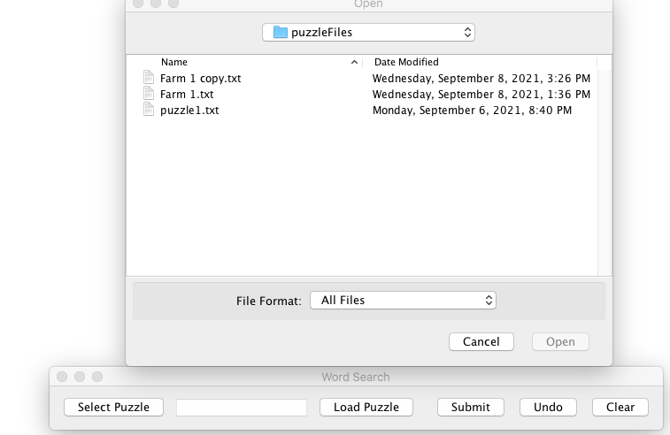

Figure C. New implementation using JfileChooser to select files.

In sum, the word search’s development is on schedule. Integration of the module that reads data files with puzzle information and the completed prototype is scheduled for phase two. The user guide and test plan will be updated to reflect the new file selection process.

### E. Slider Puzzle

The portion of the Java game suite that I worked on this week is a picture slider puzzle. My goal for phase 1 was to have the GUI complete and begin to implement the button handlers and other controls so that I could have a prototype by the end of the week. First, I created a GUI that presents the user with a 4 x 3 grid of image tiles, a brief instruction informing the user how to complete the puzzle, an option to change the puzzle, and puzzle hints that display the completed puzzle image. I did not encounter a lot of issues when creating the GUI other than resizing the image files so that they would not appear distorted as a complete image or as individual image tiles. Below is an image of the GUI after launching the program:

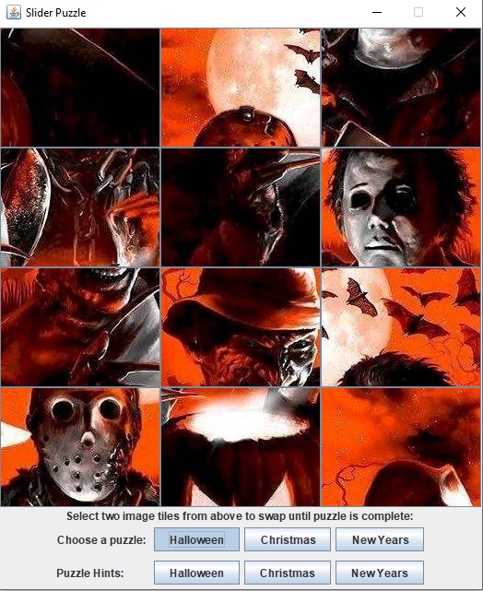

Next, I implemented the button handlers and other controls that allow the user to complete the puzzle, choose a new puzzle and display the puzzle hints. Below are screen captures of the GUI after choosing a new puzzle and selecting a hint:

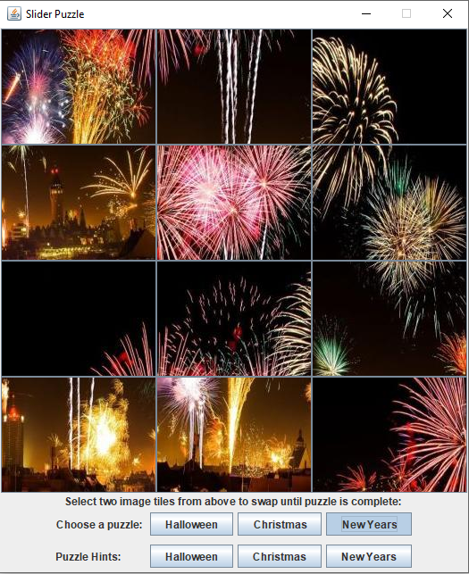



Lastly, I needed to make sure the winning combination would display a message to the user informing them that the puzzle is complete:

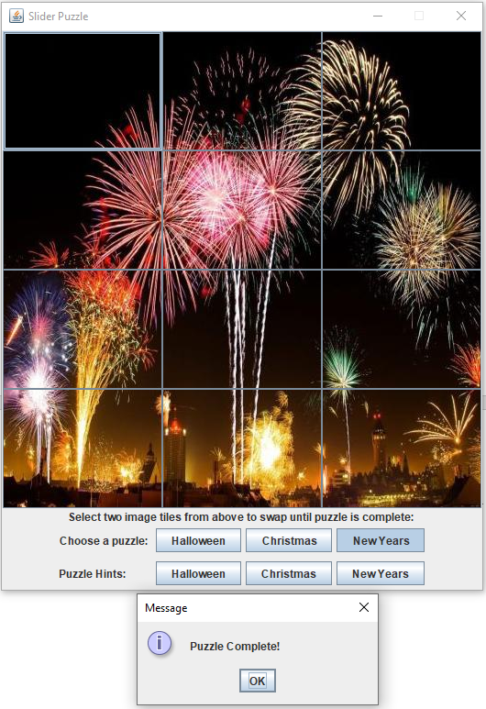

Overall, I feel that phase one was successful because I have a working prototype. Moving forward, I will be focusing on improving the GUI and its functionality, as well as focusing on integrating the game with the complete Java game suite.

## 6.4 Phase 2 Report

### A. Maze

For this phase in the project, I created 9 additional levels and beta tested the levels for glitches and inconsistencies. I also began test running levels to make sure they are winnable and not very difficult. The levels are supposed to get progressively harder and I am also trying to make sure there is enough to keep the players interested without potentially frustrating them.

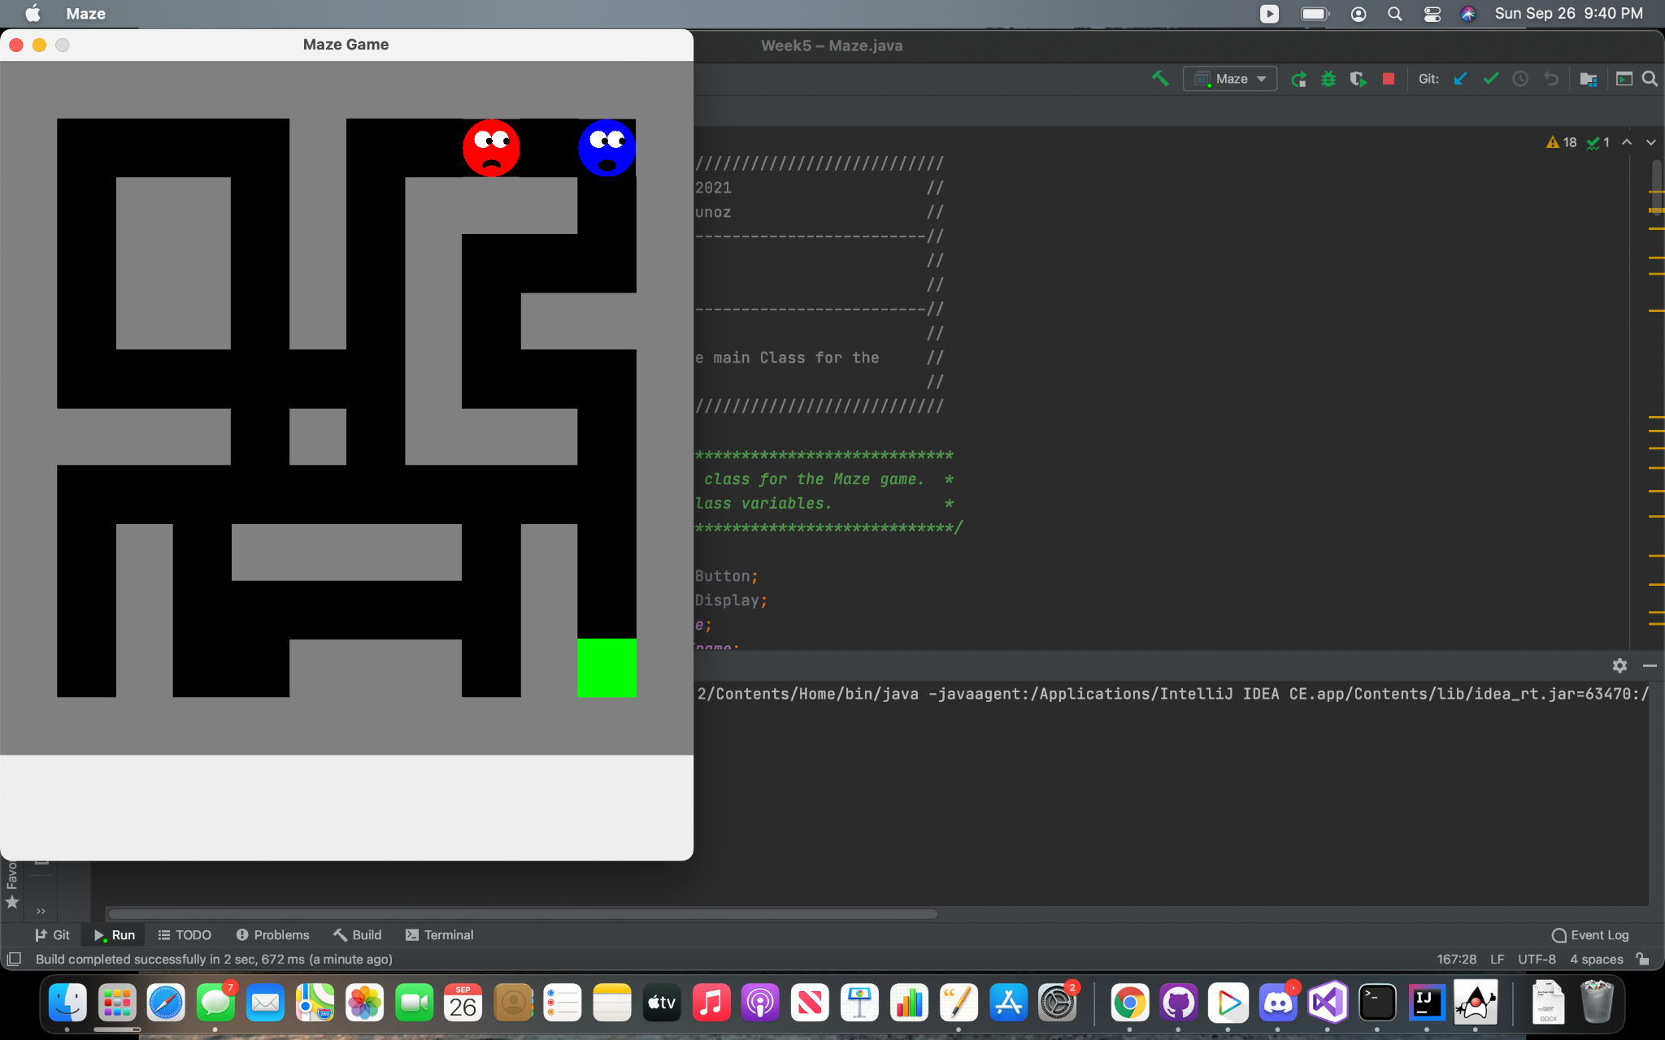

### B. Snakes

Phase 2 is completed on the snake game app. The snake will consume an apple and grow in length, with each end of the snaking being a different color so that users can differentiate the head from the tail. Like many games, the levels become more challenging the further the players progress. I’ve also settled on a grid size for the player. I realized that the larger the grid size, the longer the game will take to switch from easy to difficult. Phase 3 will be to polish my code and fix any remaining bugs in my game.

 

### C. Sudoku

For Phase II, the Sudoku puzzle is a working prototype. The production of the Sudoku game having one difficulty level across various games was a better option for the game development. The code now has zero errors and runs. Once the code is executed, the first initial game is displayed. The user will have the option to proceed with that game and fill in the missing numbers. If the user chooses not to complete the first initial game that is generated, then there will be an option to choose a new game. As they keep choosing the new game option, a new game will be loaded and displayed to the user. One change that I am trying to configure code for would be to add a timer. The timer would show the user how much time it took them to complete the puzzle. The timer would automatically stop and calculate the time once the puzzle has been completed. Throughout the upcoming week I will be working on the timer portion of the code to see if it could be incorporated. The timer would be a great feature, just in case the user would like to know the time it took for them to complete and if they wanted to improve on their time.

Proceeding with what I have for this phase, I continued minor testing to ensure that the Sudoku program was still producing the product that I needed it to. I would like the timer to be displayed beside the ‘Exit’ button. At the initial start of the game, it will start as 0:00 until the user makes the first move then the timer will begin to count upward. At the end of the completed game the timer will show how much time it took for the user to complete, location still beside the exit button.



Timer Location start time 0:00

Figure 1: User is presented once Sudoku is chosen from the main menu. Timer will be displayed as 0:00 location beside the ‘Exit’ button.



Timer Location: completed time

Figure 2: User has completed the game. User can select New Game to play again (new game board generated) or Exit Game to be directed to the main menu. Game completed the timer will display the time taken to complete the puzzle.

### D. Word Search

I successfully completed the word search program’s phase two goal, which was to produce a complete functioning prototype where the user can select a puzzle, the puzzle loads from a file, the user can interact with the GUI to find the words, and the program displays a score upon clicking the submit button. Since I already implemented the GUI interface in phase one, phase two focused on backend development in which I created the PuzzleGenerator class, which reads in a puzzle file and creates objects to be used by the GUI layer. Phase two also involved adjustments to the GUI display as well as implementing and testing the scoring function.

First, I implemented the Word and PuzzleGenerator classes. The programming of both was straightforward as I already decided the structure of the test files and devised the algorithm for reading them in the design phase. After testing that the PuzzleGenerator read in the files and assigned them to data structures as intended, I linked it to the GUI. This was relatively simple and involved removing the hard coding I used to get the GUI display up and running and finishing implementations of the load file function that reads in data from the PuzzleGenerator class.

The first design challenge I encountered was that hard coding the size of the letter fonts on the search grid could be problematic. I have a small laptop screen and too large of a font with too many rows made part of the JFrame not visible. I also did not want to fix the JFrame’s size in case someone was using a smaller or far larger screen. My solution was to first determine the user’s screen size, then calculate what I felt was an acceptable font size based on those measurements, and pass that to the puzzle generator to set the font size. I also decided a maximum number of columns and rows for puzzles that would work with this ratio. In phase three, I may want to allow the user to increase font sizes of the letters on the grid and words on the word list panel separately to make the program more accessible to the vision impaired.

The next challenge was efficiently scoring the words that the user found correctly. I originally planned on using set operations. First I would create a set containing all the sets of letters that each line intersected. I thought the most efficient approach would be to perform a set difference between this set and the set of hidden words, the difference producing the unfound words. However, I realized that I could not create word objects from the sets of letters that intersected by the user’s highlights that would match the hidden words easily. In phase 3 I may try to create a custom comparator. In the interest of time and considering that the number of hidden words and potentially found words is always going to be small, I decided it was not that inefficient to just iterate over the hidden words and compare their inner set of letters to the each of the sets of letters intersected by the user’s highlights. As seen below, I implemented turning the font of the unfound words to red and displayed a JDialog box with the score. I also implemented clearing the entire panel when changing puzzles, which I found did not work as expected when tested.

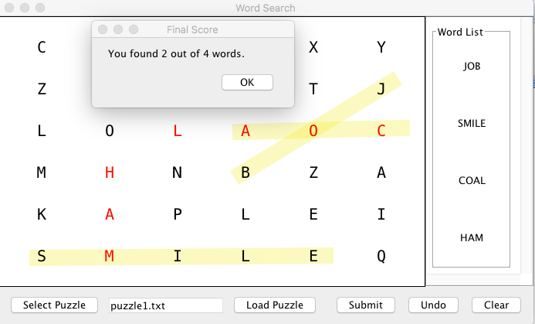

Figure A. Implementation of word search scoring and display of unfound words. Note that “coal” was not completely highglighted so correctly not counted as found.

Phase three will involve minor tweaks to the program, such as fixing the display in which the user has to drag the JFrame in order to reveal the puzzle when it is loaded and adding additional puzzle files.

### E. Slider Puzzle

The goal for phase 2 was to continue coding the GUI for the slider puzzle, implementing the required methods, adding action listeners, begin testing, and integrating the slider puzzle into the main menu. Below is a screen capture demonstrating the launch of the GUI from the main menu:

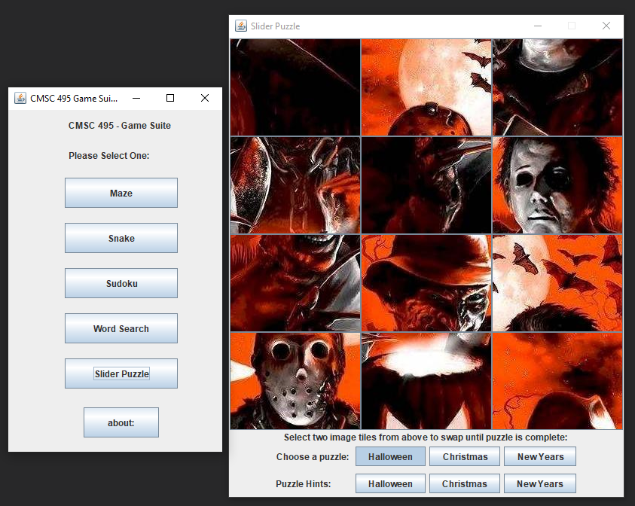

All the required methods and action listeners were successfully implemented in phase 2. The program now allows the user to swap the image tiles and detects when the puzzle is complete. A message is displayed that informs the user that the puzzle has been completed. I also adjusted the code so that the main menu does not close when the slider puzzle is exited. This will allow the user to launch multiple games at once. Moving forward into phase 3, the goal will be to integrate the slider puzzle into a package containing all the java games and to continue testing.

## 6.5 Phase 3 Report

### A. Maze

In this phase, the timer and deathCount function was added. The program was modified so that items and the map can scale. This was built to overcome problems with the maze being too large for the screen.

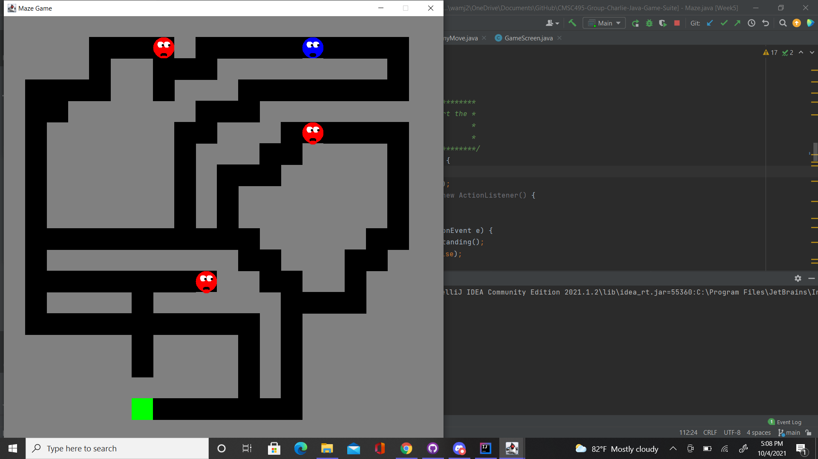

Figure 1: Example of Scaling the maze for larger fields.

With the introduction of timekeeping, two threads are now being used; one for the enemy movement and the other for the time lapsing. This has initially caused exceptions to be thrown where either functionality would stop. The threads for both were modified and the program runs without errors. The high score will now show up on the opening screen rather than as its own menu.

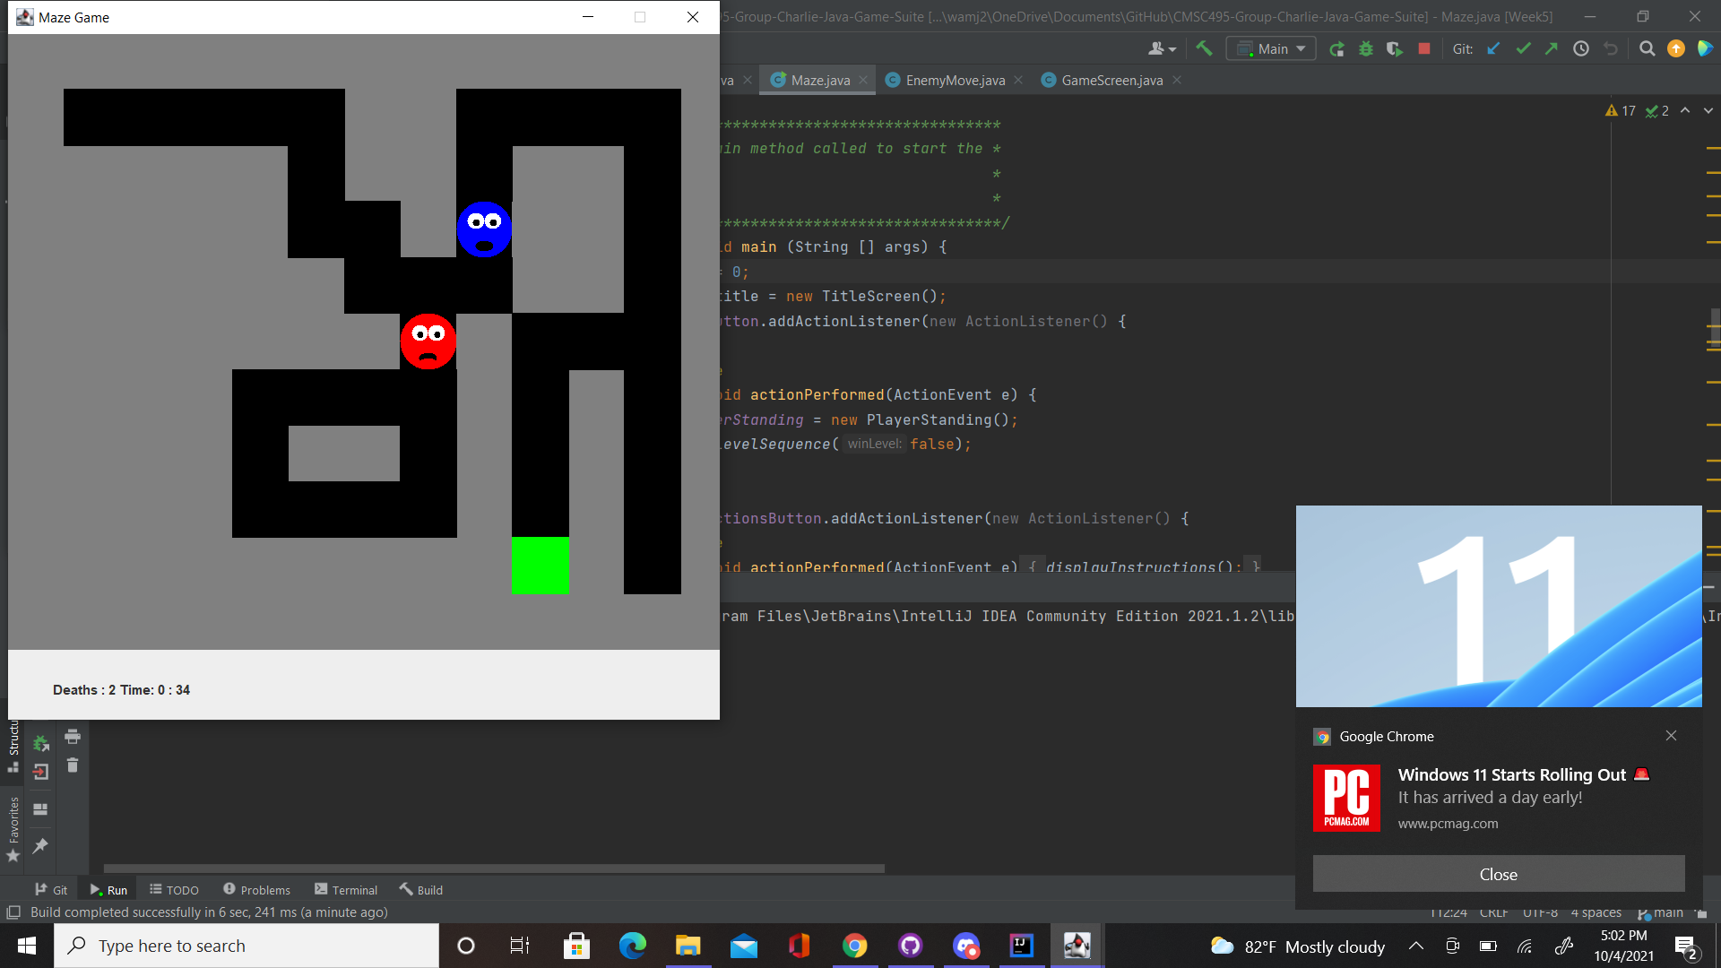

Figure 2: Challenge where you have to lure the enemy to get around it.

Some level modifications have also been added to make going to the exit the main challenge. For this reason, the enemy placement now plays a role in the difficulty of the maze.

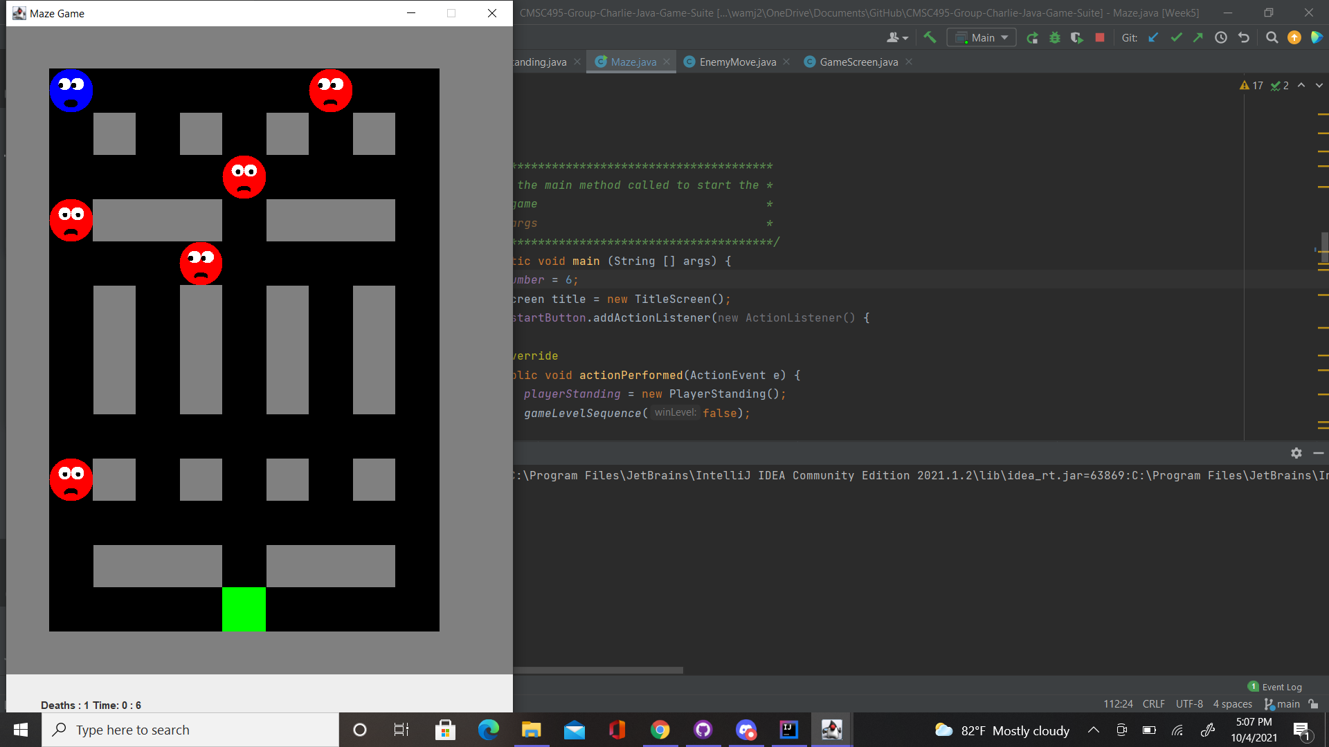

Figure 3: Challenge involving multiple enemies.

### B. Snakes

Phase 3 is still pending. However, I had selected an ideal speed for and created an out of bounds feature that will trigger an automatic game over when crossed by players. Refer to figure 1.2.



Figure1.2

The Grid size from phase 2 has also been coded into the snake game. The goal for phase 4 is to polish my code, fix any remaining bugs and test all games with my team members.

### C. Sudoku

For Phase III, the Sudoku puzzle was tested throughout the week for continuity purposes. Mentioned in phase II, I was going to attempt to incorporate a timer. As I was doing this the code was having issues, so I decided not to continue with adding the timer since I had a working project/prototype to begin with. The code for the sudoku puzzle went through testing well and did not produce any errors. Once the user chooses Sudoku from the main menu, the initial game will be displayed to the user. The user will still have the option to proceed with that game or choose a new game by clicking “New” to be shown a different board. As the user continues to enter the numbers in the appropriate box, the “Check” option can still be used while playing the game so the user can see the progression of the game. To choose a number, the user simply selects any number they would like to start with. Once the user finishes inputting the numbers in the boxes the numbers will grey out and can no longer be clicked. This acknowledges to the user that the number chosen is complete and to proceed to the next number. When the user has completed the puzzle, they will be able to use the “Check” option to make sure that the numbers were entered correctly. Lastly, once the user has completed the game, they have the option to “Exit” game to go back to Main Menu and select another game or “New” game to start a new game.



Figure 1: Once application is running the Main Menu is displayed, user chooses Sudoku to play.



Figure 2: User is presented initial game once Sudoku is chosen from the main menu.



Figure 3: User will select a number i.e. “1”. All the locations where a 1 can go will be displayed in blue. The user will be able to click on the box that they want the 1 to go. The blue display is annotated by the “Help on” check box. User will be able to turn this on or off depending on if they want the help. User will proceed with each number with the same concept.



Figure 4: User checks progress. Green annotates that number is entered in correct block. Red annotates that number is incorrectly entered in block.



Figure 5: User has completed the game. User can select New Game to play again (new game board generated) or Exit Game to be directed to the main menu.

### D. Word search

I successfully completed the phase 3 goals for the word search program, which was to add any additional features and perform initial testing and debugging. Before testing, I first enabled the user’s highlight to appear dynamically as they dragged the cursor over the letters rather than only appearing after they released the mouse.

I performed two types of initial testing and debugging: using the test plan and free play by myself and other users. First I successfully passed the tests in the test plan, which I will update in the final documentation after the team also tests the game. The program displayed the available puzzles, the test puzzle loaded and displayed as expected, and the hidden words were displayed on the list panel. A strikethrough successfully appeared or was removed through each word on the list when clicked. The user was able to drag their cursor over the letters in the grid to highlight words. Clicking submit presented the expected unfound words to appear in red and the correct number of correctly identified words to be displayed as seen in Figure A. The program rejected invalid highlights. The undo button removed the last highlight and the clear button cleared the entire board.

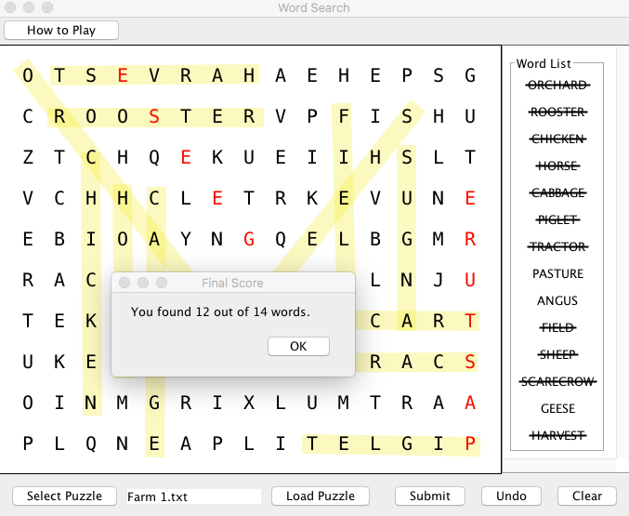

Figure A. Actual display of unfound words and appropriate score.

However, I did not just rely on the test plan and unexpected bugs were caught while I was programming and playing the game. For example, I noticed that the red letters from the unfound words remained when clearing a puzzle in order to replay it. I will update this in the test plan. I also fixed an issue in which the user has to drag the JFrame after loading the first puzzle in order to see it.

The second round of testing involved observing and informally interviewing a couple of test users. This was very useful because those outside of development process have different perspectives and are not influenced by their own knowledge of how the game functions. Through this process I discovered several additional features that I needed to add or think about including in the future. First, I discovered that a user could inadvertently clear the board with the clear button, so I implemented a dialog box that checks if the user wants to clear everything (Figure B). Secondly, I discovered that while buttons were labeled in what I thought was an intuitive manner, users might prefer an option to briefly read the game’s instructions and they may not want to refer to the user guide. I thus implemented a button and dialog box to display short instructions on the game’s functionality seen in Figure C. Third, I discovered that not all users have the dexterity to draw a single stroke across the center of the words. This program was intended for the general user so I did not make any changes. However, I may want to consider a more accessible version of the program in the future. Doing this would change the underlying logic of how I detect words. Lastly, I discovered that users may try to keep highlighting and submitting puzzles even after the solution was displayed. This is not necessarily a problem, but not behavior that I anticipated and I changed the code to prevent this from happening.

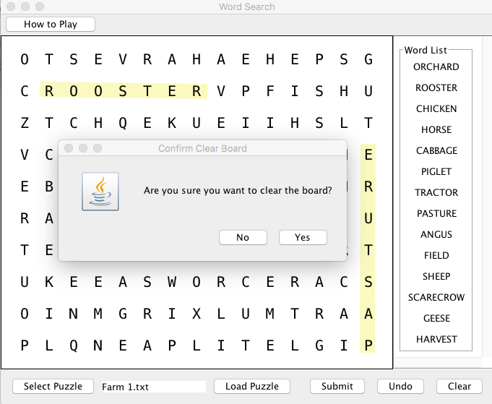

Figure B. Clear board confirmation dialog box.

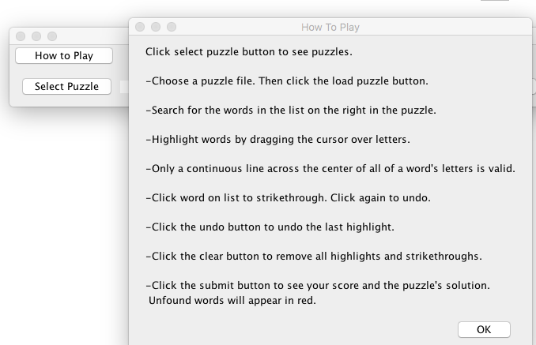

Figure C: Image of game play instructions.

### E. Slider Puzzle

The goal for phase 3 was to integrate the slider puzzle into the main menu and start testing this portion of the Java Game Suite. After loading the main menu of the program, I selected the slider puzzle option. This successfully displayed the slider puzzle GUI. This is shown in the screen capture below:



Next, I tested to make sure that the user can load a new puzzle. Once a new puzzle Jbutton was selected, the program loaded the correct image files:

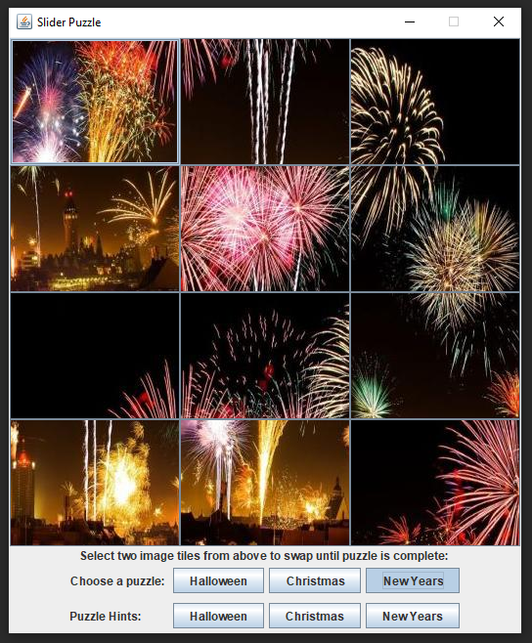

After the puzzle is rearranged correctly, a message is displayed informing the user that the puzzle has been completed:

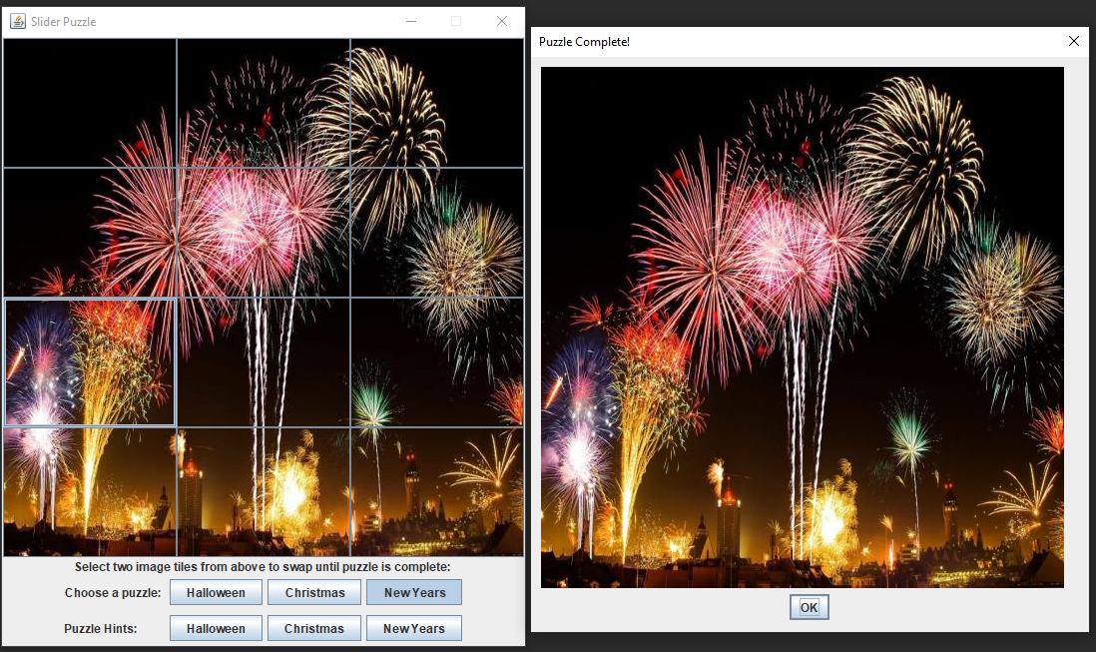

The next thing that needed to be tested is the program’s error handling. If an image file is not found, a message was successfully displayed informing the user that an image file was not found:

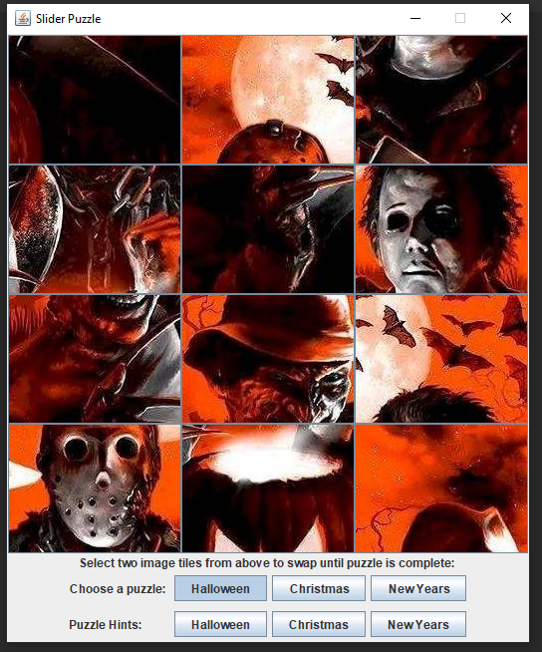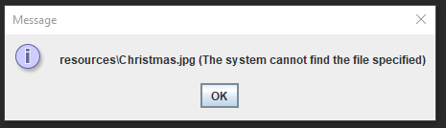

Lastly, I tested to make sure that the program does not exit the main menu once the slider puzzle is closed. This ensures that multiple games can be launched at once.

### F. Main Menu/ Game Integration

Combining all programs and testing that they could all launch from the main menu was another goal for phase three that was successfully accomplished. Initially, when the individual programs were combined, different team members were either not able to launch all the games or received compilation errors. The solution was to place the files for each game into separate packages. Another issue that was discovered and resolved was that closing the window on everyone’s individual programs closed the entire program, which was not the behavior specified in the project’s requirements. In Phase 4 we will continue testing the main menu and individual programs as well as package the game suite into one executable file.

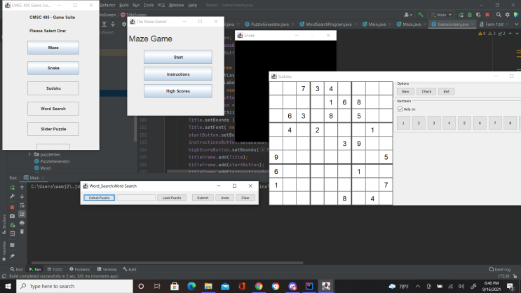

Figure 1. Image of games launched from main menu.

## 6.6 Phase 4 Report

### A. Testing

Several issues were identified during testing the entire game package. When executed from the command line both the Slider Puzzle, Snakes, and Word Search programs demonstrated problems loading files from their subdirectories. This was fixed by updating the relative paths used to access these subdirectories to include their package level directory. The main issue identified for the Maze program was that the part of the frame for the last maze was not visible on smaller screens. This did not affect game play. No significant problems were found with the refresh rate on Macintosh and Windows operating systems, which was a concern. Two issues were identified for the Sudoku program. The first was that clicking the exit button exited not just the Sudoku program but also the main menu. The second issue was an intermittent display problem where the red and green color after clicking the “check” button or the blue hints for one number would temporarily remain after requesting the program display hints for another number. The team also attempted to use a jar file to allow the user to easily execute the program. However, we identified that the user must have the exact java version that we used to compile the program and thus opted against it.

### B. Additional Notes on Individual Programs

#### B.1 Snake

I ran into a problem where the snake game would not load the resource whenever a player launches the game from the main menu. I realized the path specified in the code was incorrectly pointing to the wrong path. My team gave me the necessary feedback to locate and fix the issue. The snake game now runs fine with no issues or error. The final code has been uploaded to GitHub and combined with the code base.

Error:

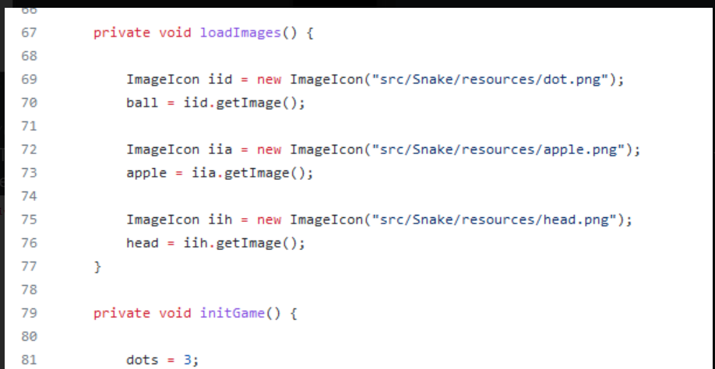

Fix:

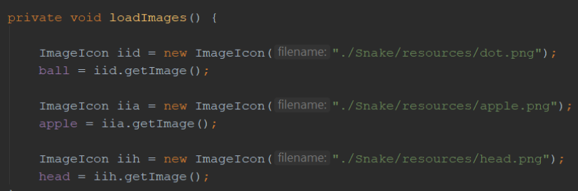

#### B.2 Sudoku

For the final phase, the Sudoku puzzle was fully completed until the testing when the entire project was put into effect. When the user would choose Sudoku from the main menu, played the game and pressed the ‘Exit’ button it would then exit out of the entire program, instead of going back to the main menu. With the help of my teammates, I became aware of this problem as I was not having it until I started testing the entire program for myself. The solution that would fix this problem would be to remove the ‘Exit’ button and have the user click the ‘X’ in the top right-hand corner in order to close out the game once it was solved. By doing this, it would not close the entire project and the user could continue to choose another game to play from the main menu.



Figure 1: Sudoku game once initiated from the main menu. Removed the ‘Exit’ button, once game is complete user will use the ‘X’ in the right-hand corner to exit the game. Once complete will bring user back to main menu.

B.3 Word Search

The main issues I had to resolve for this phase revolved around the user’s access to the WordSearchPuzzle directory where puzzle files are stored. First, I noticed that users could attempt to open files from different directories when using JFileChooser. I thus used a file system viewer to only allow the files from the WordSearchPuzzle directory to be visible. Secondly, when integrated into the main menu, I noticed that this directory could not be opened, as stated in the testing discussion above. I determined that this was due to the fact that I was using a relative path. In standalone development, I assumed that the present working directory was the directory in which the WordSearchProgram’s main function was stored. However, once integrated into the package, the present working directory switched to that of the Main Menu’s main function and the word search program’s path had to be updated to include its package level directory.

# 7. Conclusions and Lessons Learned

Overall, Team Charlie found this project an excellent opportunity to learn about the process of software development and effective teamwork. We agree that the communication strategies we employed (direct meetings and chat) and the use of a code repository contributed to the success of the project. Furthermore, our team worked effectively by leveraging our individual strengths. In the future, development of the game package would potentially include additional features for individual games, enhancements to the look and feel, and allowing more ways for users to play and interact with the game system. Below are our individual reflections on this experience.

Oyewole Sansui:

We were able to learn a lot from this lesson. One of the things that we learned was that a system like this takes time to develop well. In fact, if we had more time to work on it, I believe we would have games good enough to publish on steam or other gaming platform. We also would need more time in the sense that most of us work at another job, so we could not give our full attention to this project. If we had done this, I believe our project could have been that much stronger. We did however play on each other’s strengths, which is why our project turned out so well and why we as a team did not have many disagreements. We all brought up new ideas and had others cross check our ideas with each other to ensure we are producing the best product we can. Another way to improve this project would be to add more games and include feature that enables players to hookup gamepads, change resolution, include multiplayer, and capabilities for streaming. Overall, I believe that we did an amazing job with our project and I would work with my team again.

Wayne Mack:

The design strengths of this project as a community was that we were able to effectively communicate with one another. The mediums were very organized and we designated meeting times and maintained communication through message boards. There were times where somebody's experience and know-how came in handy for somebody else and we were all able to collaborate for solutions. Unlike game jams and other events made popular by video sharing sites, there was no drama or arguing.

My individual design strengths were that I was able to have the satisfaction of knowing that I improved on data structures, algorithms and some of the object oriented details, something I had trouble with in earlier classes. The maze project was honestly a generic idea and the features and structure was thought up as I went alone even though I had a general idea of what I wanted to accomplish. The weakness was the maze game was almost Atari 2600 / Commodore VIC-20 quality and that was sort of unsatisfying. Also, the code structure may have been better suited for a checkers or Reversi game but, I wanted to stick with what I originally said I would do because I wanted the challenge. I loved reading the other team member’s source code. There were some aspects of organization that I used to make mine more efficient. I was also able to draw on some of their programming techniques.

Janee’ Jones:

Throughout the 8 weeks, I enjoyed working with the team to accomplish the weekly objectives for the class. From my personal experience, I have not worked with a group doing an entire project online. Each team member worked well together and completed their portion of the project so that we could be successful. Our means of communication was on point. I personally had never used either Discord or GitHub before, so this was a learning experience for me. The overall game suite coming together watching it grow week after week was interesting. The problems that we encountered over the weeks, we would come together as a team and identify the problem and figure out a solution together on how we could make it better. The final production was overall a success in what we needed to fulfill for the assignment.

Sherry Funches:

For most of us this was our first time working closely with a self-directed group on a software development project. We learned how to design and execute a complex project as a team. For instance, we learned the importance of effective, open, and continual communication utilizing weekly in person meetings and a Discord chat server to bridge asynchronous work times. We also navigated how to share and update files using a Github repository and communication during our meetings. Perhaps the most important, we all learned how to identify and lean on each other’s strengths to tackle the different requirements of the project.

Individually, this was my first exposure to the entire process of software development. I learned how to think of a computer program as serving the need of a client and the importance of considering how the program should work and interact with the user before sitting down to program. As for teamwork, I learned the importance of having clear goals and deadlines, free flow of communication, and how a self-directed team could work effectively through initiative and relying and each other’s strengths, experiences, and insights. Overall, I think the modular structure of the entire program was design strength. Instead of one large game, we have several engaging games for the user to play. One area for improvement is to enhance the cosmetic appearance of the games to have more uniformity in their look and feel. As for the word search program itself, there were a few limitations and areas for improvement. First, I think that the game could be made more accessible by allowing adjustable fonts and more freedom for the user to highlight words, either with a mouse or keystrokes. My choice on how the program identifies highlighted words prevented this type of flexibility because it required a continuous highlight from the mouse. Secondly, the game could have been improved by allowing auto-puzzle generation. This would allow the user more options than the five current games or even allow them to submit a word list and play a custom game.

Jeff McGlinn:

Our group has been able to effectively work together throughout these eight weeks. This experience has provided us with an opportunity to learn how to collaborate as a group to complete a software development project. Our strengths as a team have been our ability to prioritize deadlines and productively communicate using various platforms such as discord. Also, using a GitHub repository to house all our documents related to the Java Game Suite allowed us to stay organized and complete our weekly tasks. Some of my team members, including myself, had very limited experience using GitHub, so this project has been a great way to learn how to manage projects using a GitHub repository. Our overall design of the Java Game Suite provides the user with a simple yet effective menu and five interactive games to play. If given more time, our group could address some of the program’s limitations by improving the game suite’s visual aesthetics, increasing the usability of the main menu/games, and adding additional games.